**Characteristics of SpringBoot**

Inversion of control – give the control to the framework itself, you don’t have to create the entire logic of the application yourself.

Dependency Injection – give the dependencies of different classes to SpringBoot OR DI is a design pattern where an object's dependencies (other objects it needs to function) are not created by itself, but are instead "injected" by an external container, like the Spring IoC container in Spring Boot-

Aspect Oriented Programming (AOP) – tackle down the crosscutting concerns e.g. logging in, security.

Provides us with Spring Data Libraries to connect to your database.

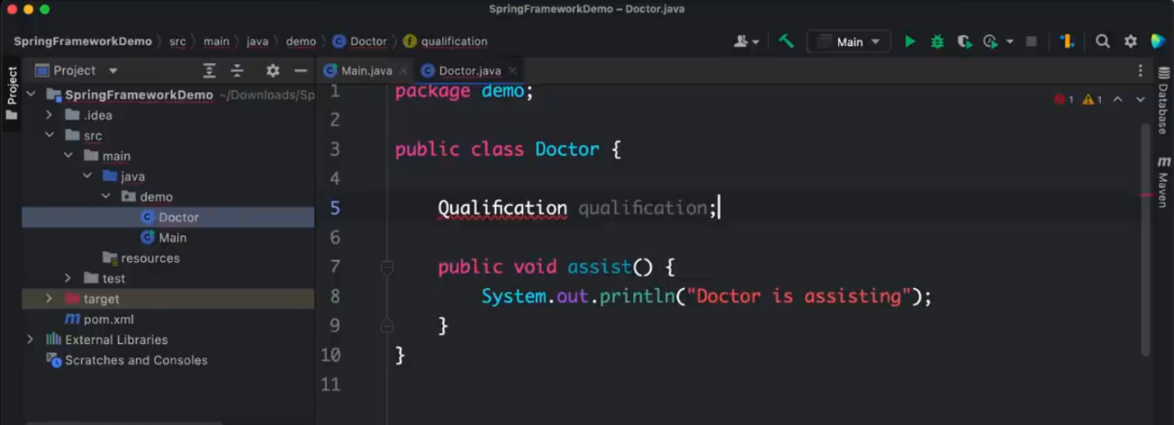

Tightly coupled class Doctor which needs the Qualification class to be instantiated whenever you instantiate a Doctor. i.e. whenever you want a Doctor class you need a Qualification class.

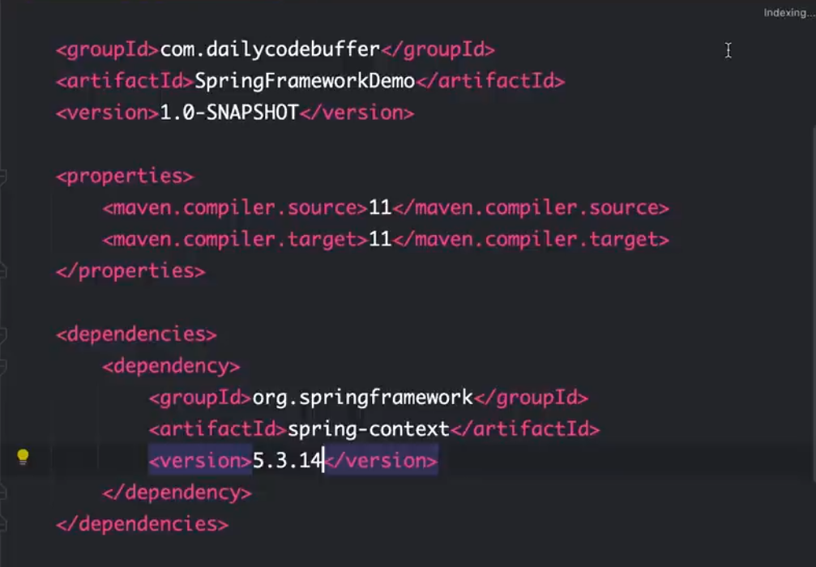

Adding dependencies.

Note: There are two interfaces available i.e. Bean Factory and Application Context from where we can get all the Beans which are loaded and use those particular Beans.

Application Context extends Bean Factory hence there are more resources in the Application Context.

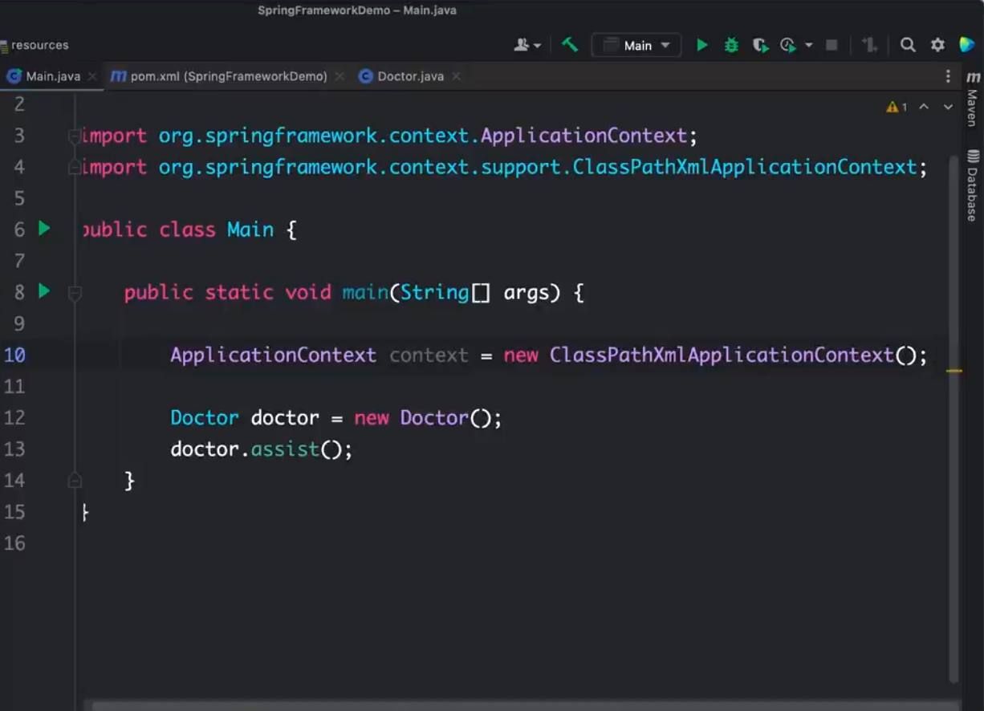

Importing the Application Context.

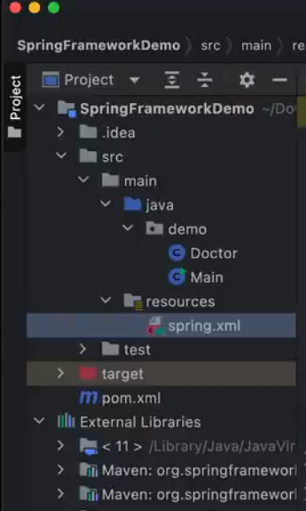

Folder structure

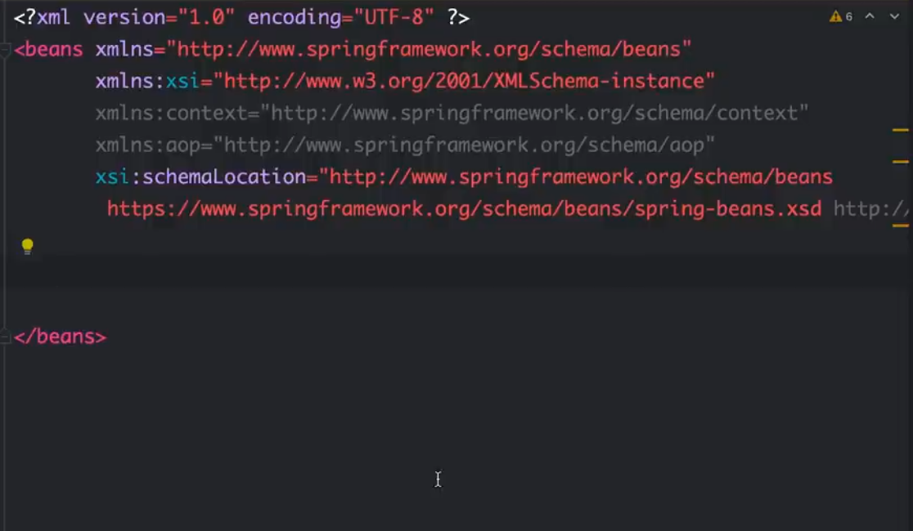

Defining the Beans in the spring.xml file. The attributes are got from the documentation for Spring boot 5.3.14

In SpringBoot, all objects are Beans.

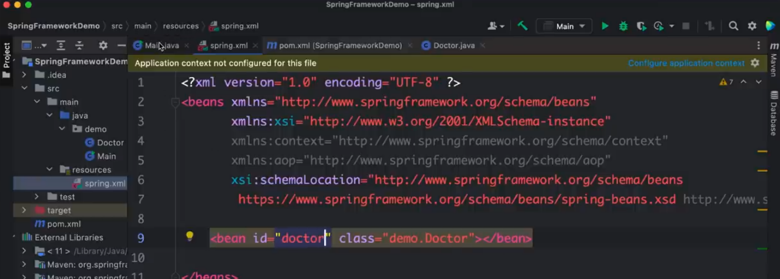

Defining a particular bean

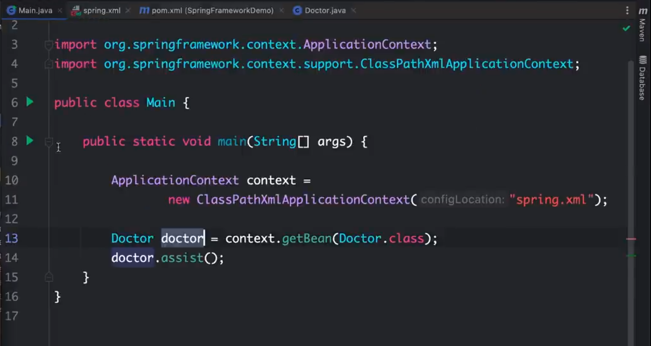

Connecting and using a particular Bean in the main class.

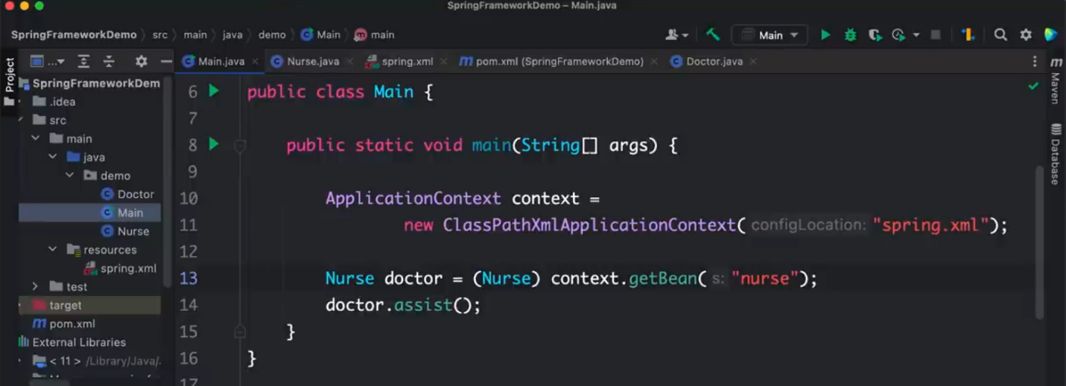

Can also get a bean by id and use casting.

**Creating a hierarchy**

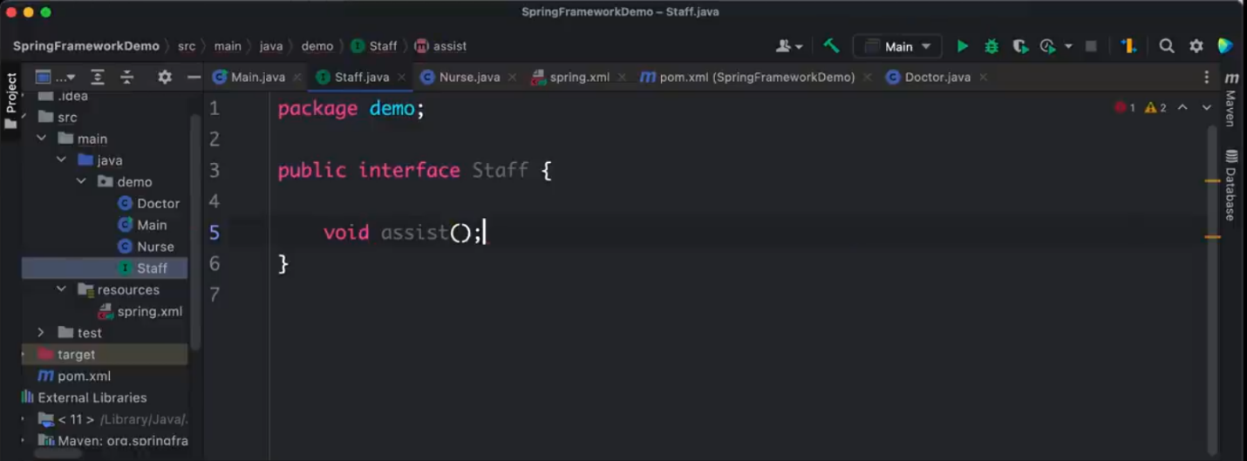

Staff interface implemented by Nurse and Doctor

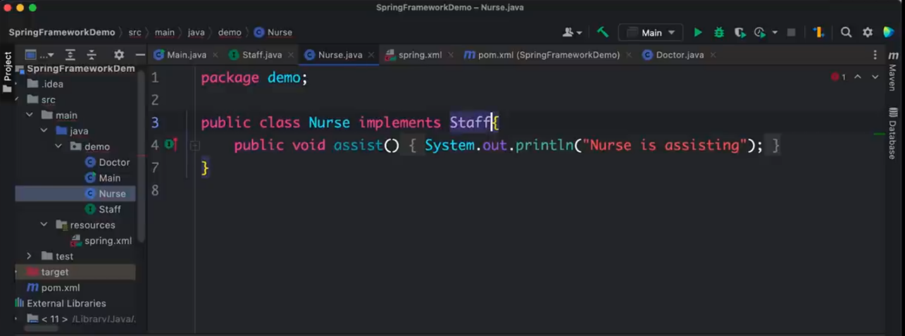

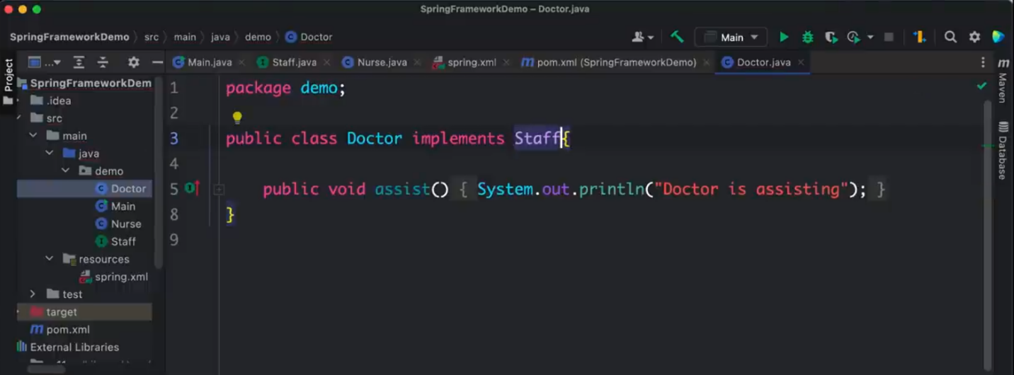

Now changing the main class to run on Staff.

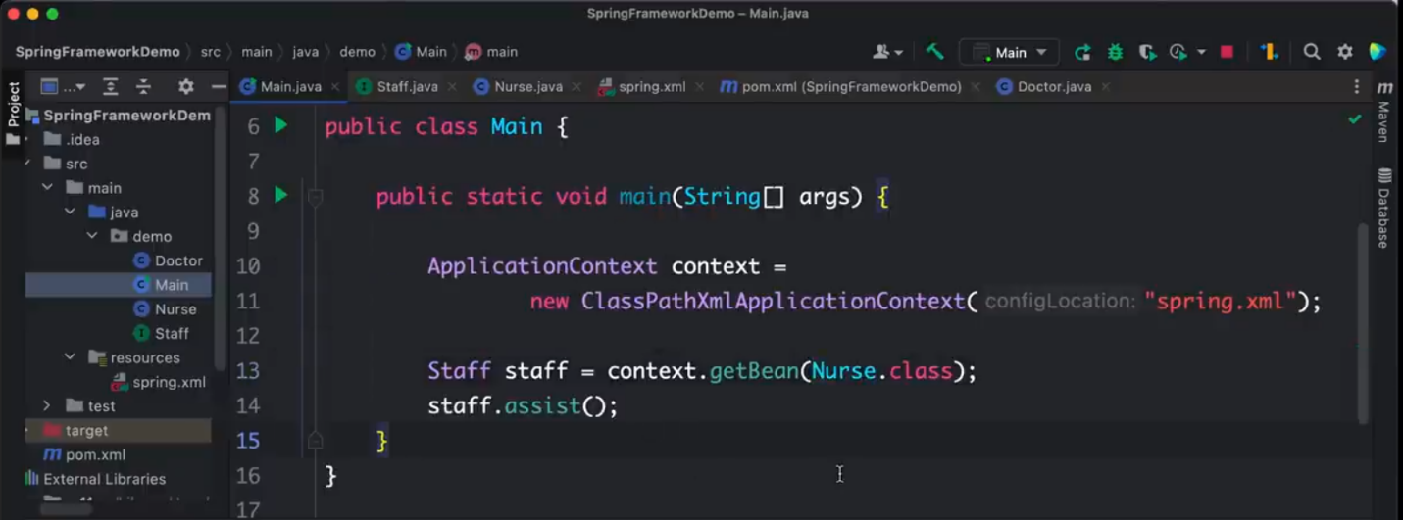

Adding Properties to the Doctor class and injecting them in the XML i.e. use setter injection. Make sure the properties have getters and setters.

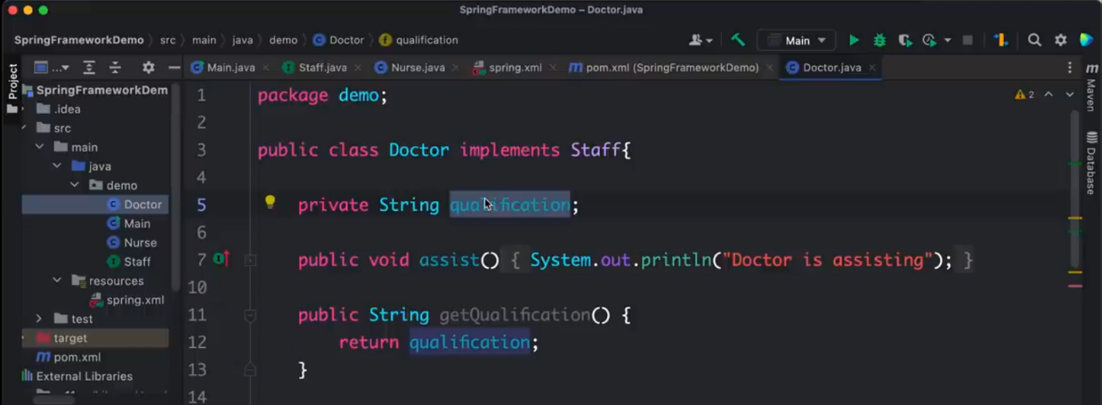

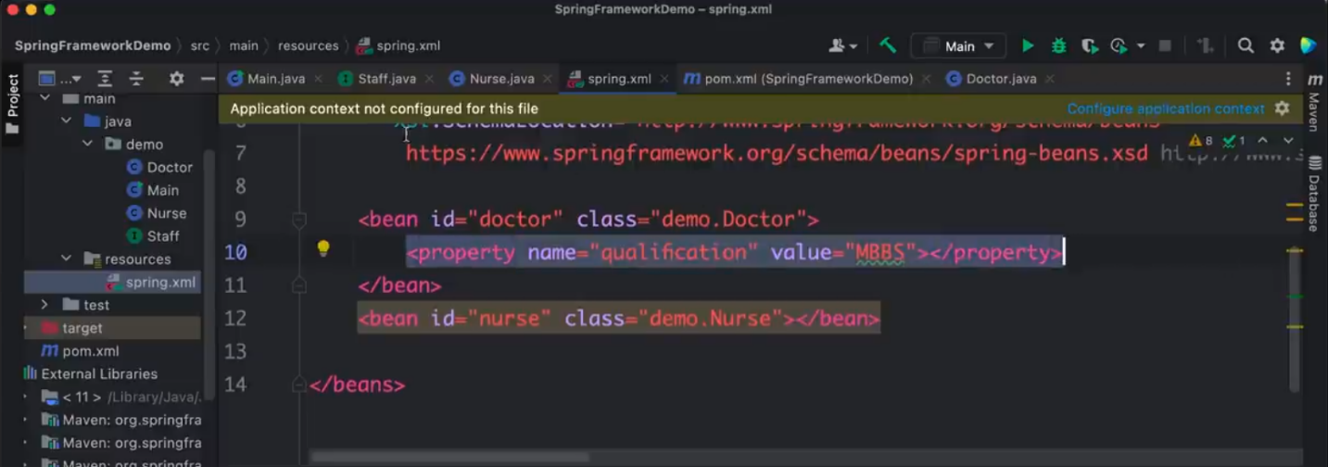

Now accessing the properties from the main class;

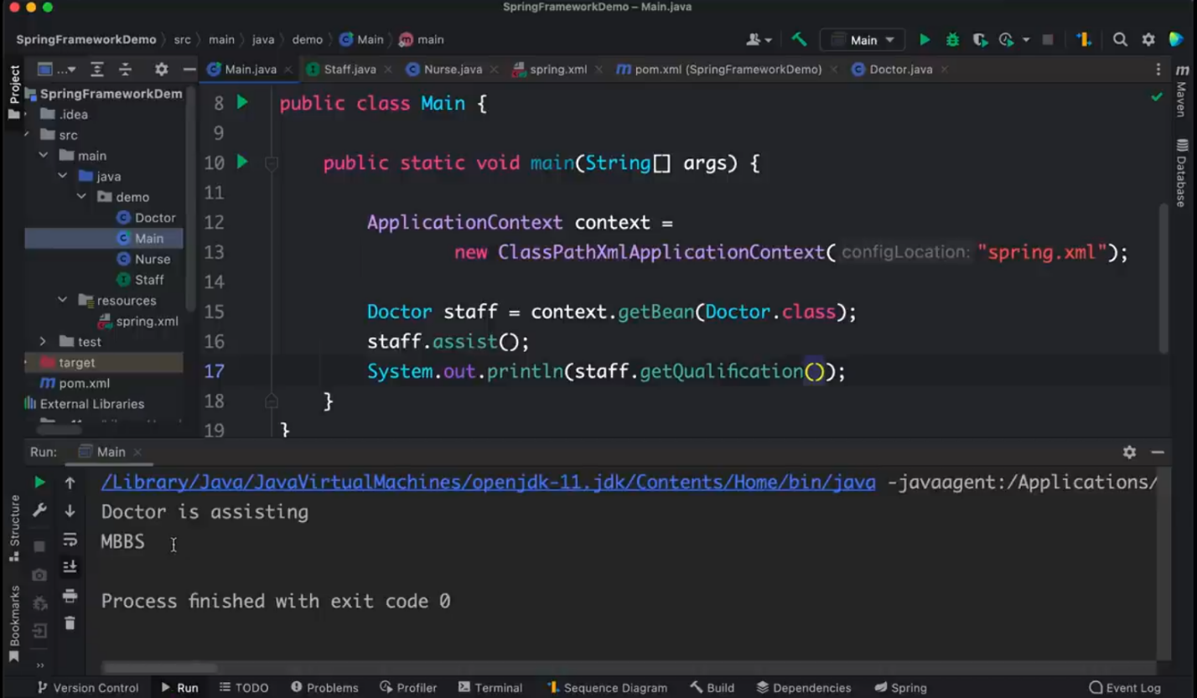

Let’s say you wanted to reference an object of a class say Nurse in doctor. Make sure you create the nurse object with its appropriate getters and setters and do the following:

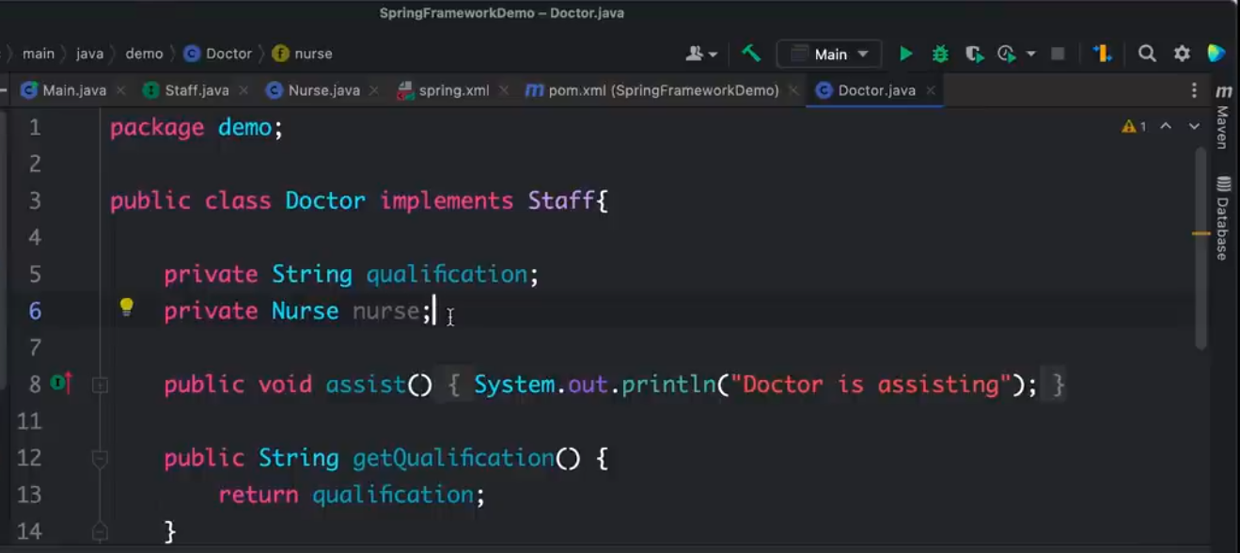

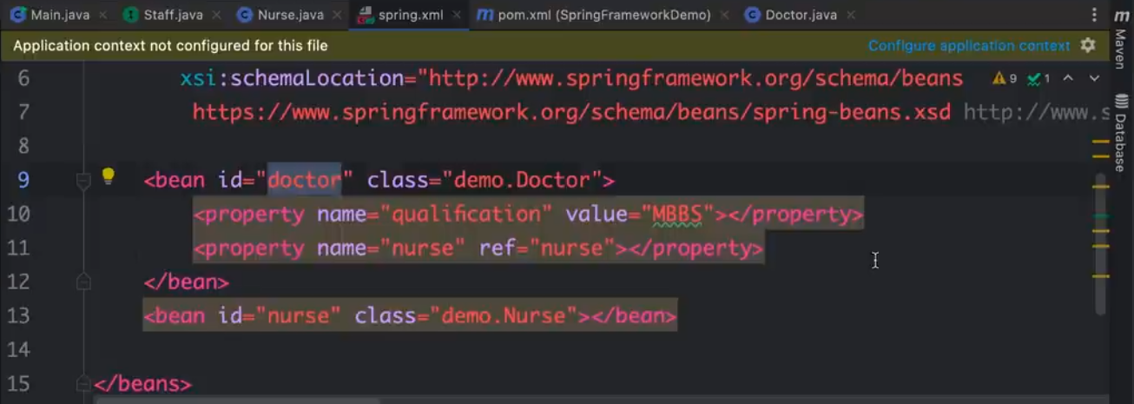

Constructor based injection can be done by:

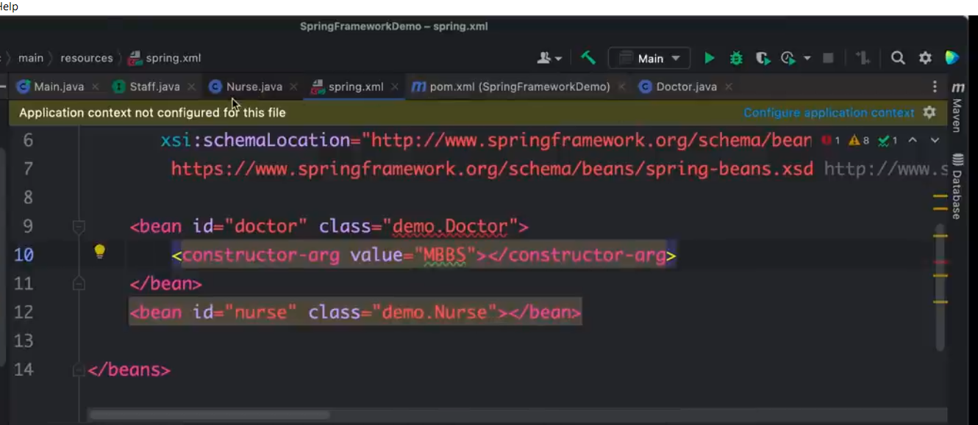

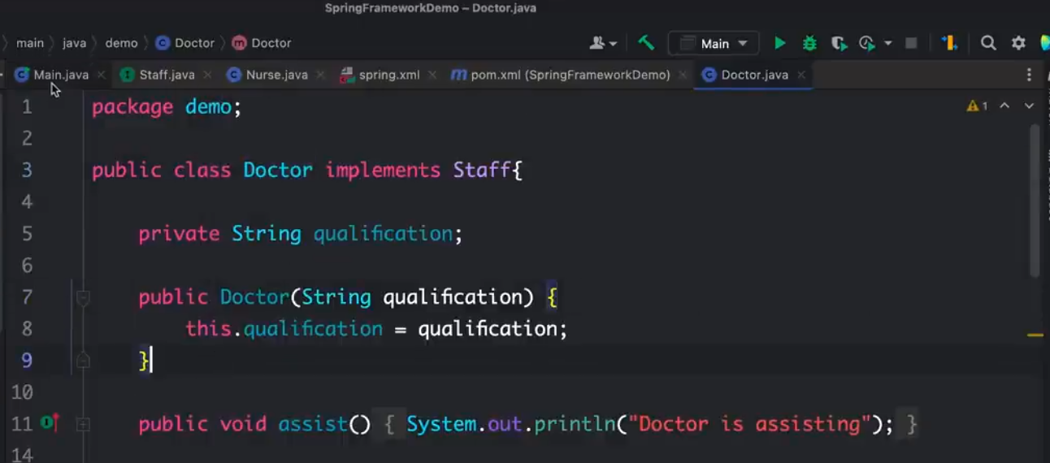

**You can also use annotations to create Beans**

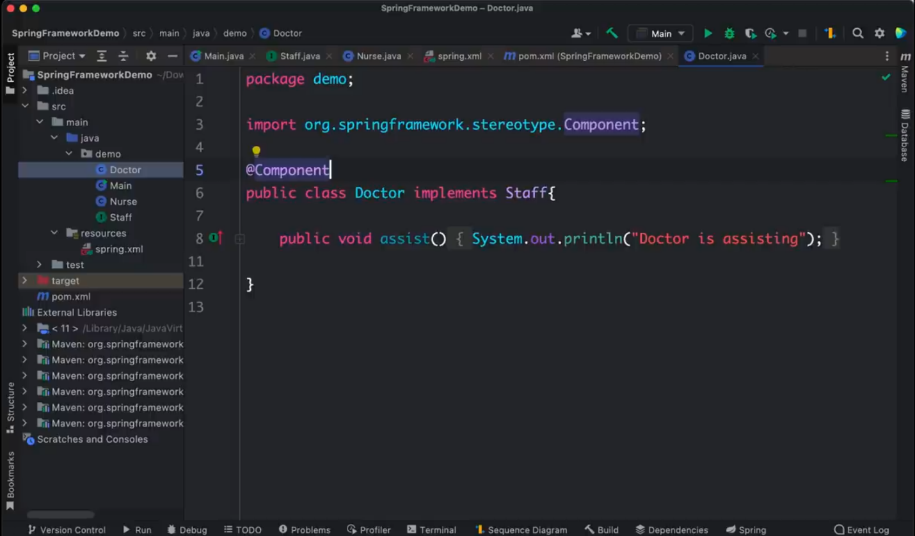

Component annotation tells SpringBoot this is a class that will be used as a bean.

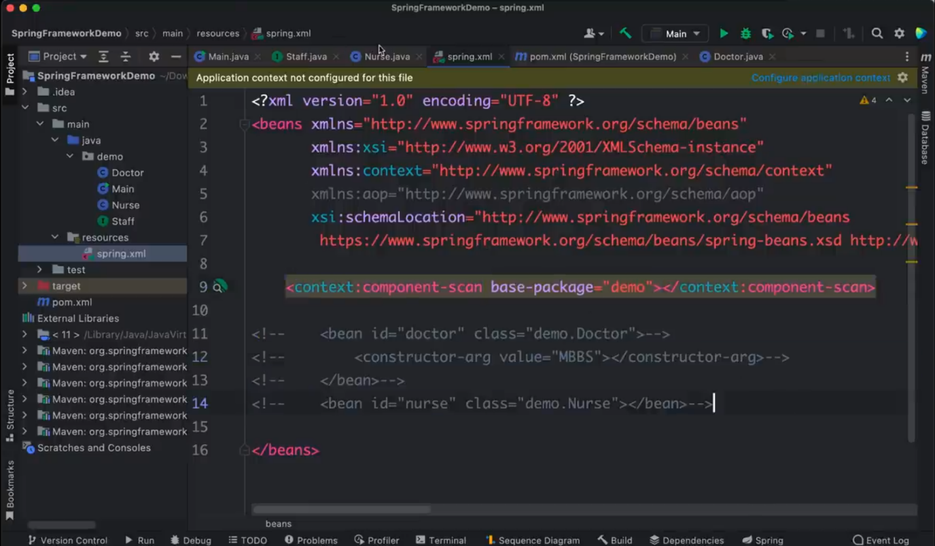

Telling SpringBoot where to search for the different Components

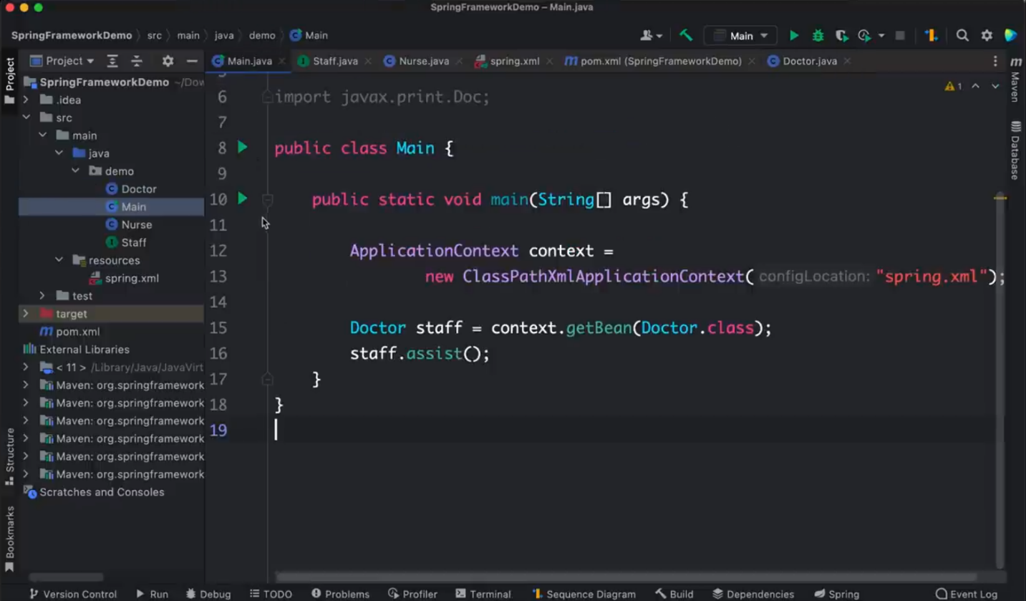

**You can also use the Java Configuration to create Beans**

NOTE: You have to create a Java Config file for this case it’s BeanConfig class. The Doctor component remains the same but this time we’re not using the XML file but the Config file

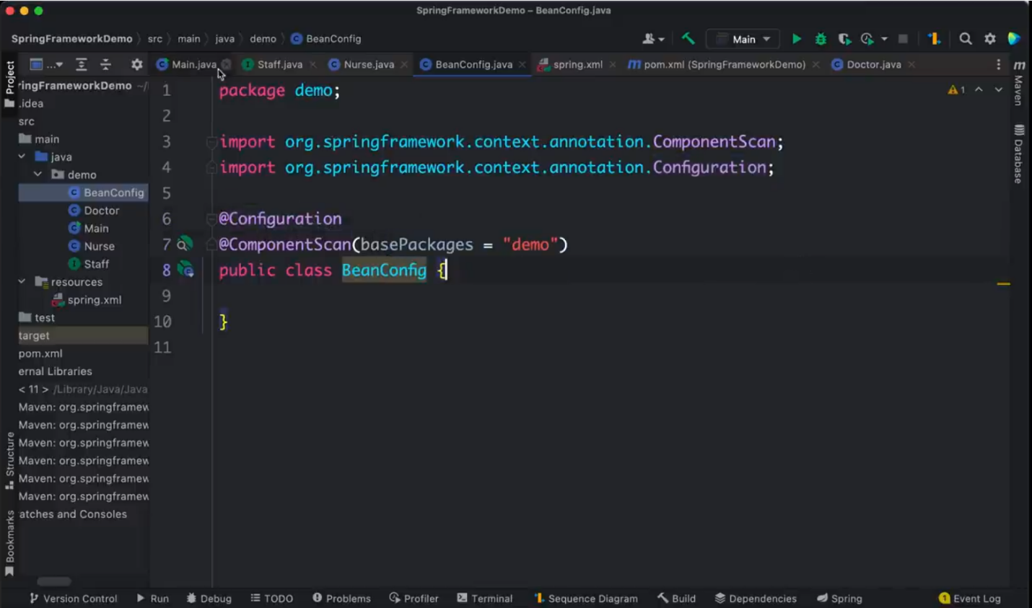

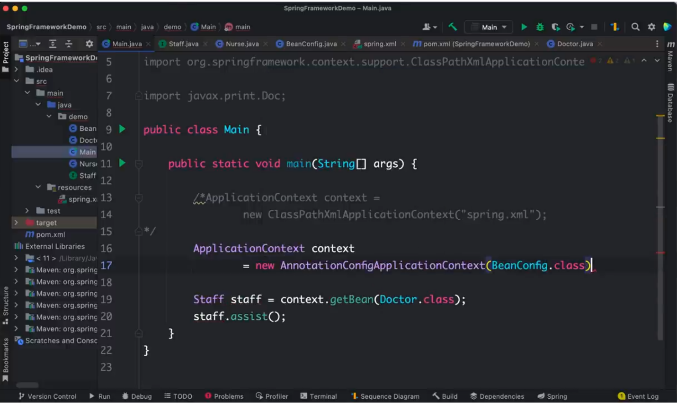

You can also explicitly define the Beans in the Config file

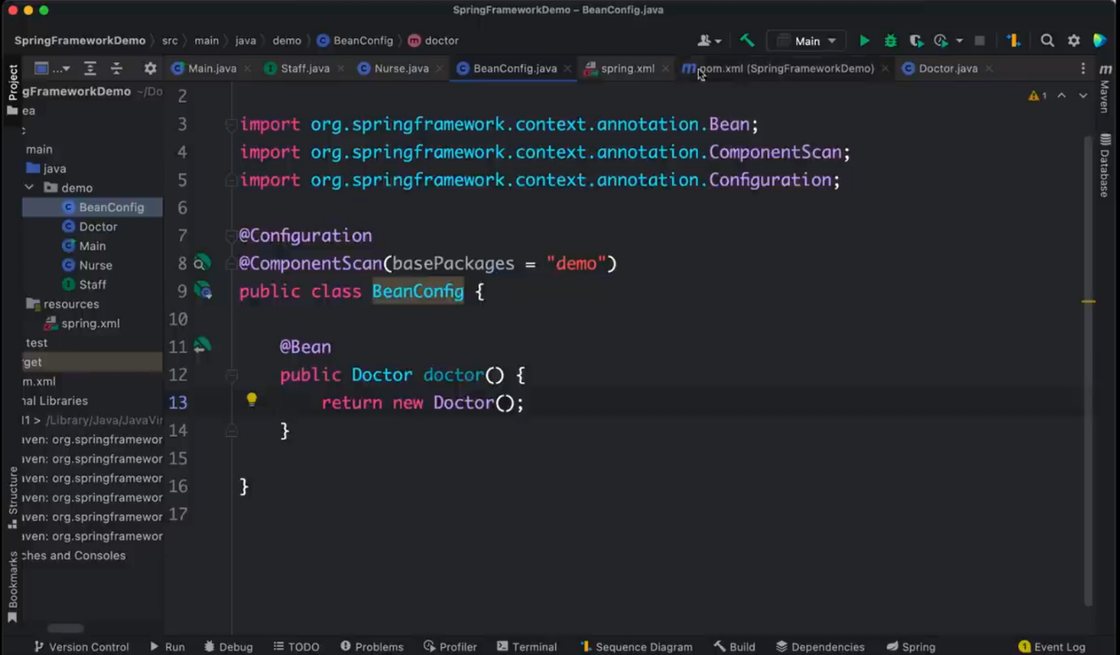

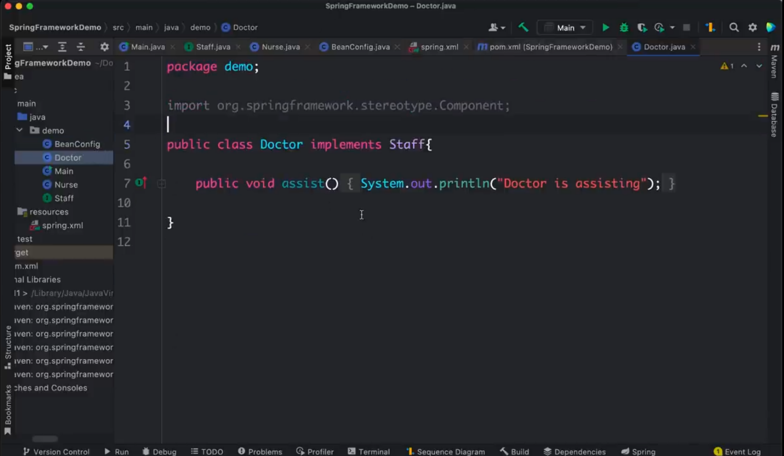

**Scopes available**

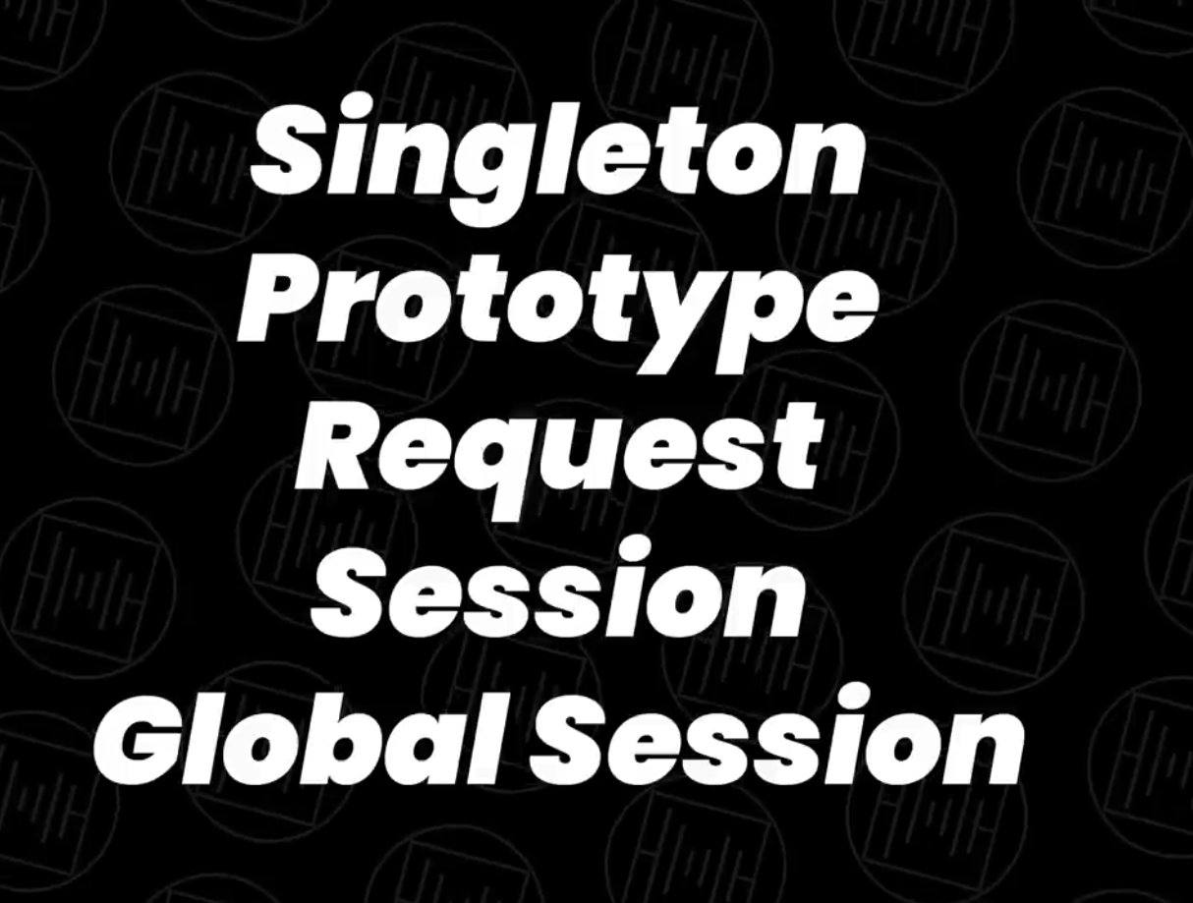

Singleton – always result into one particular object in the entire application

Prototype – get a different object whenever you request for an object from the container.

Request – need an object or different object for each and every object you request for in the application.

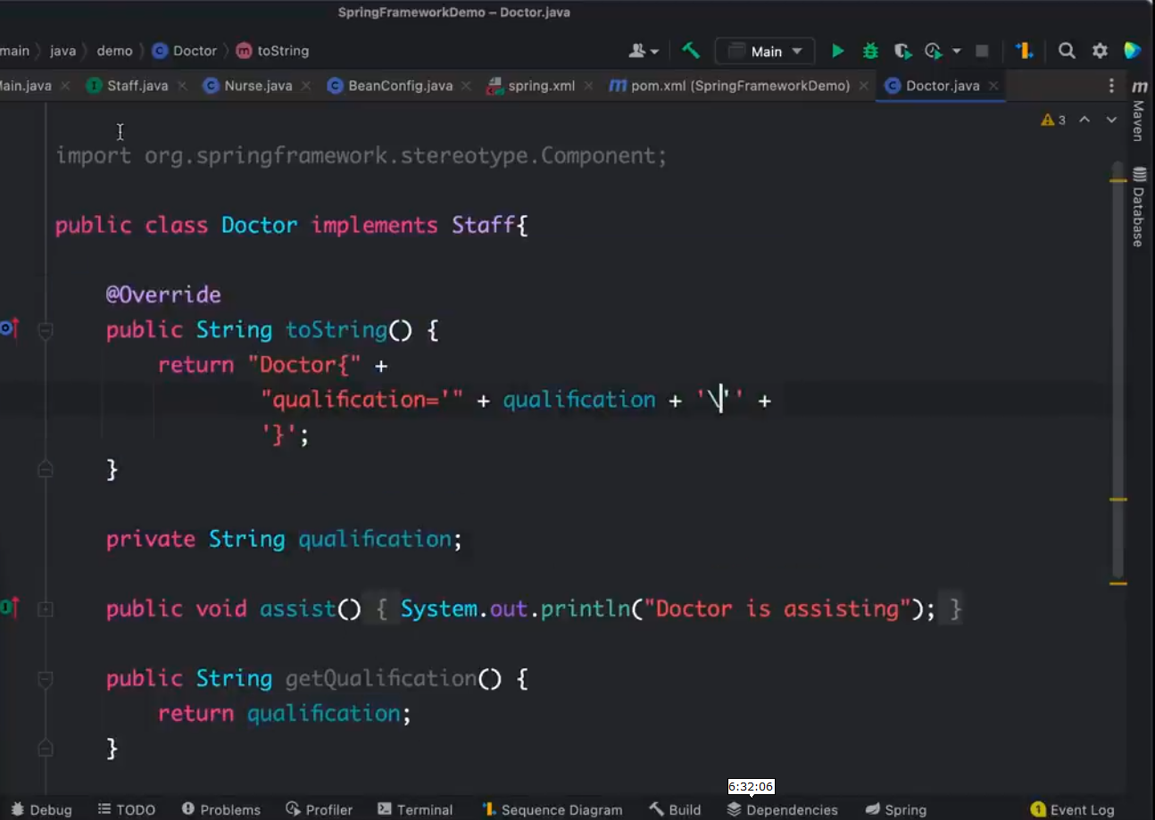

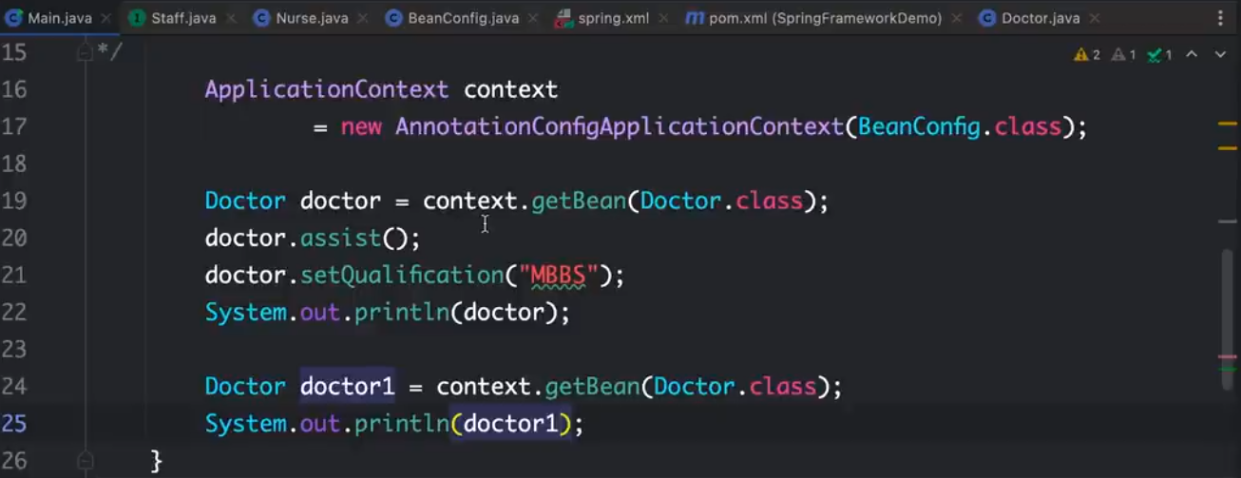

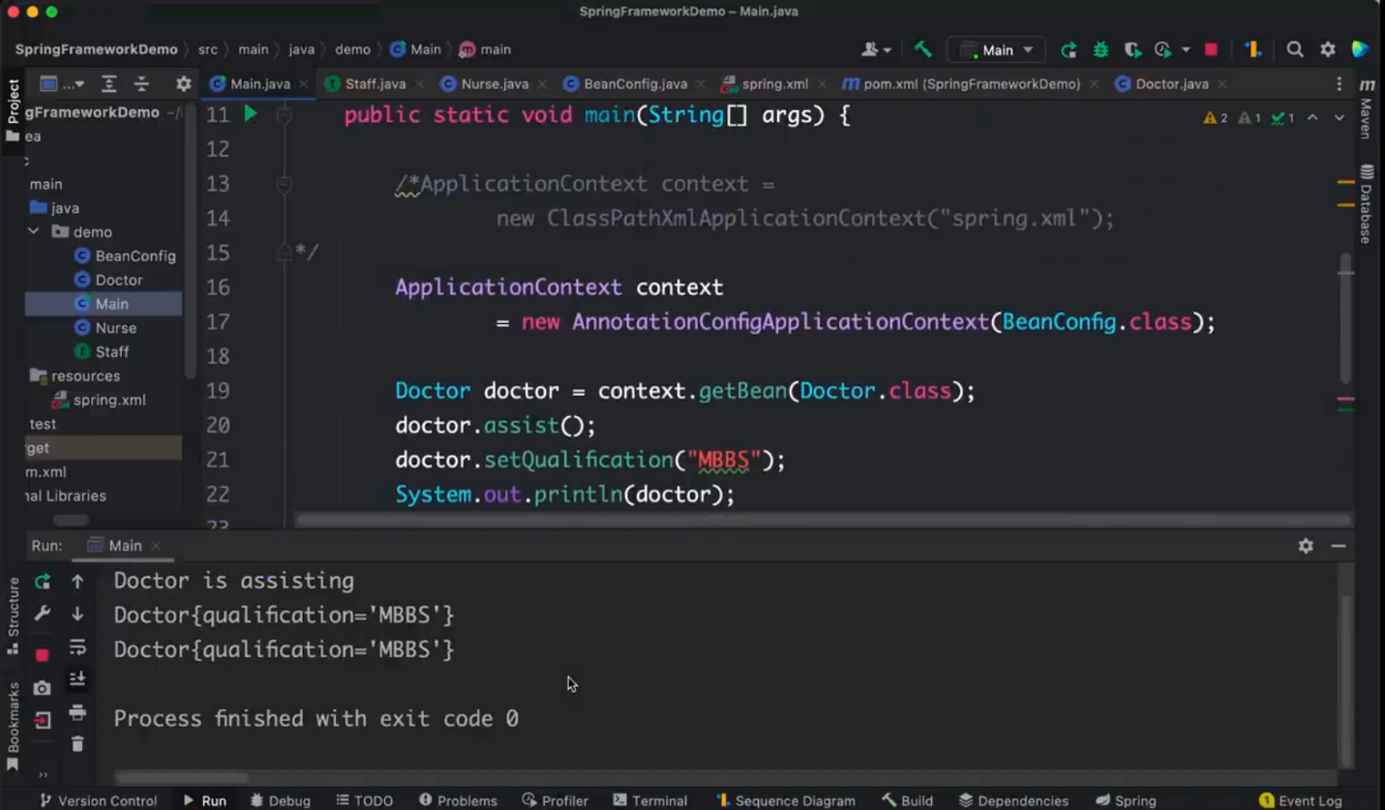

Notice you’re getting the same object back although you created different objects.

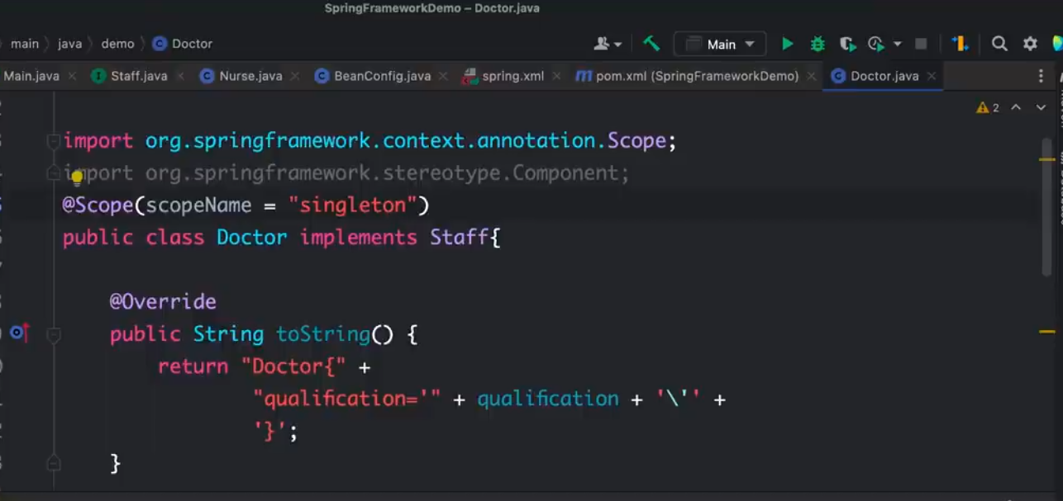

Have to give it a scopeName of singleton though that’s the default value.

Setting the scopeName to prototype results into different copies.

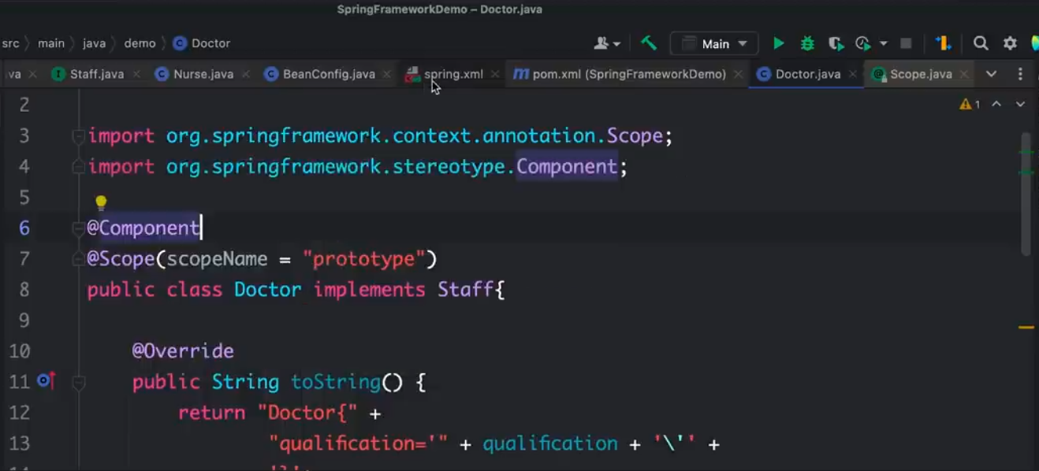

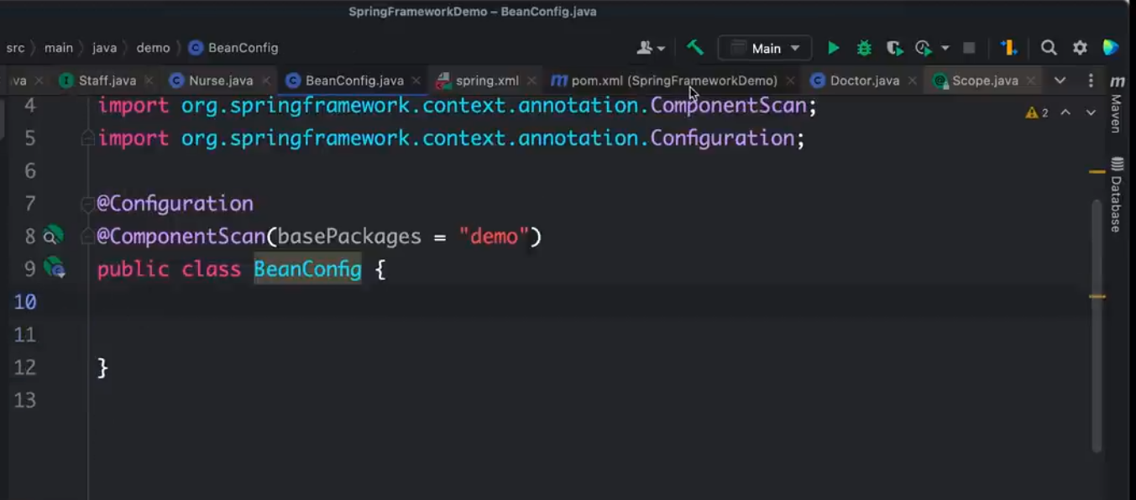

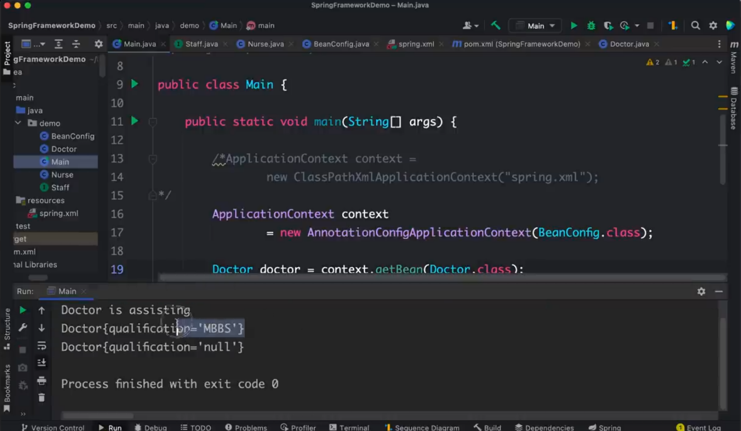

Spring LifeCycle

Definition of a Bean => Bean Creation/ Instantiation => Populate the Properties => Post Initialization Step e.g. custom executions => Serve dependencies => Pre-destroy phase=> Bin destroy.

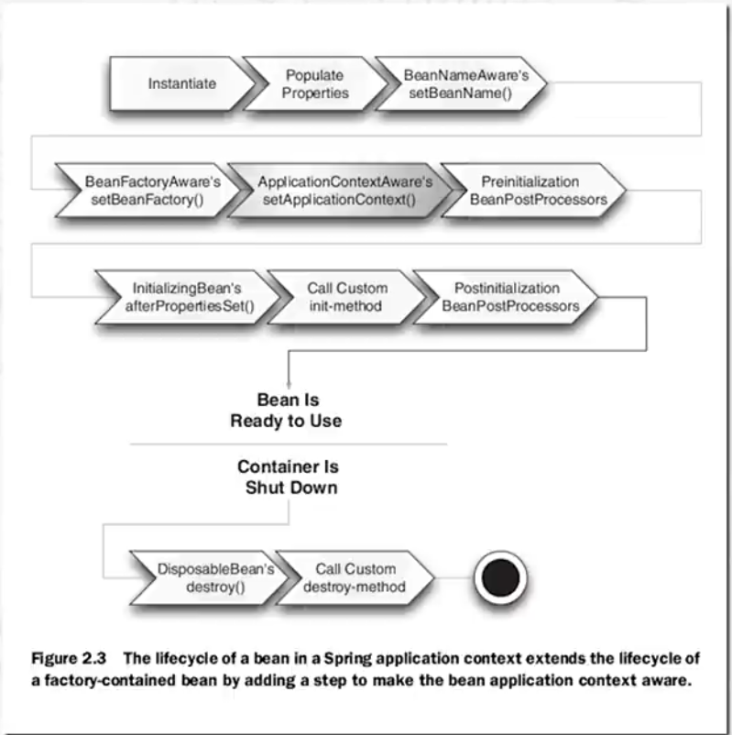

Demonstration of Definition of Bean

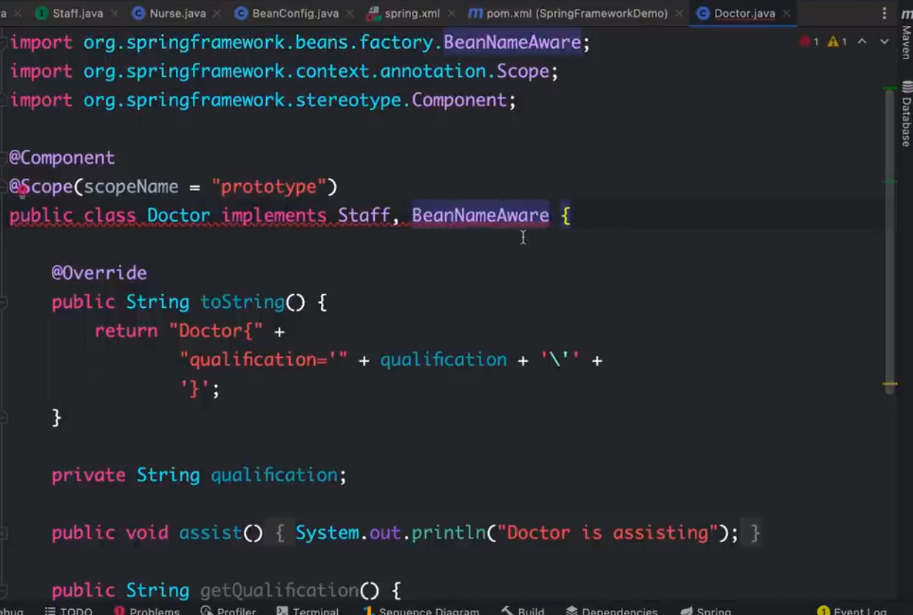

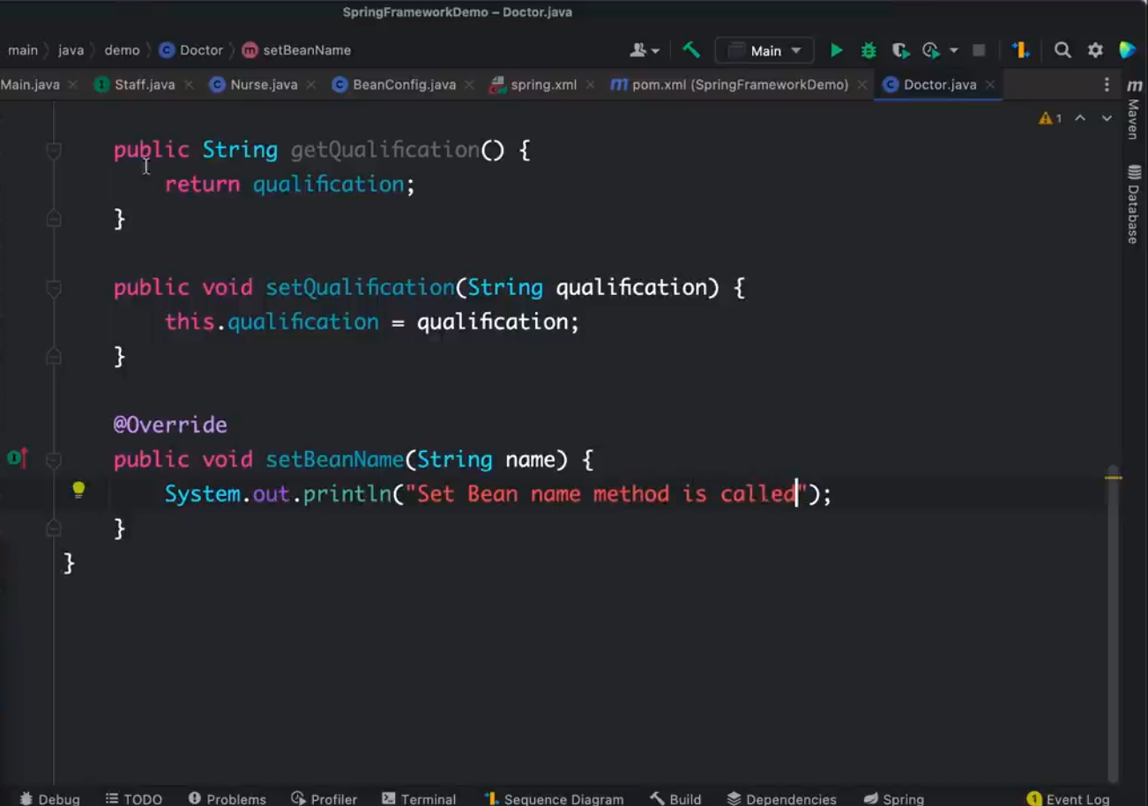

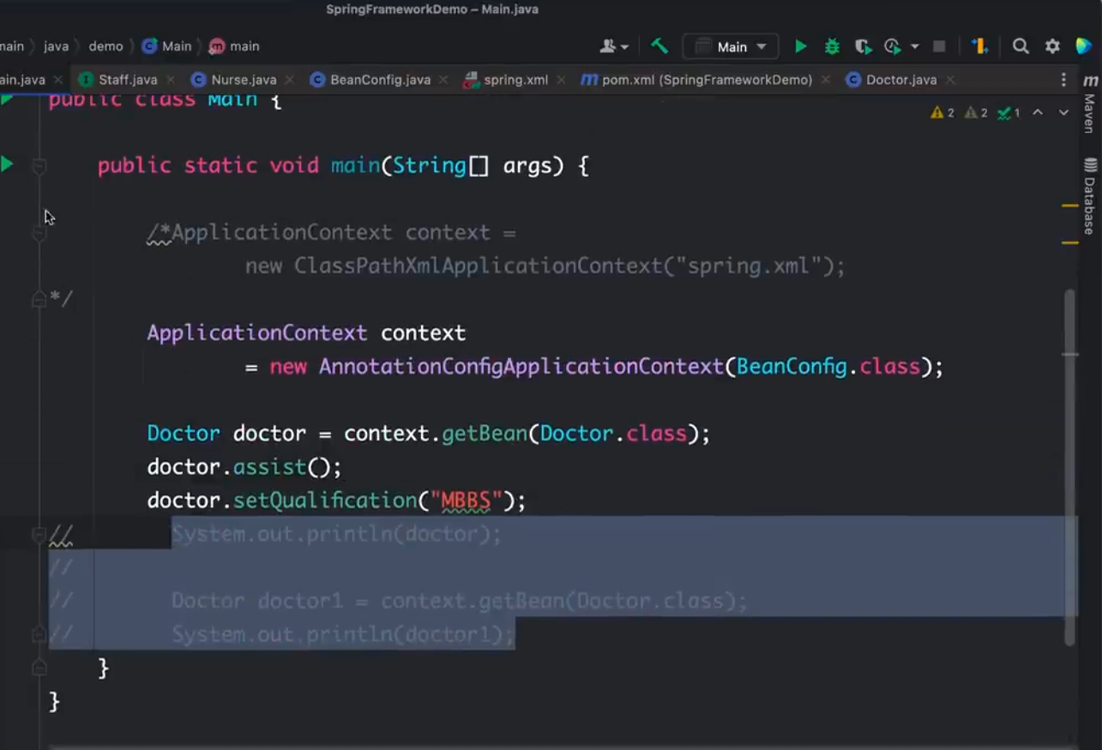



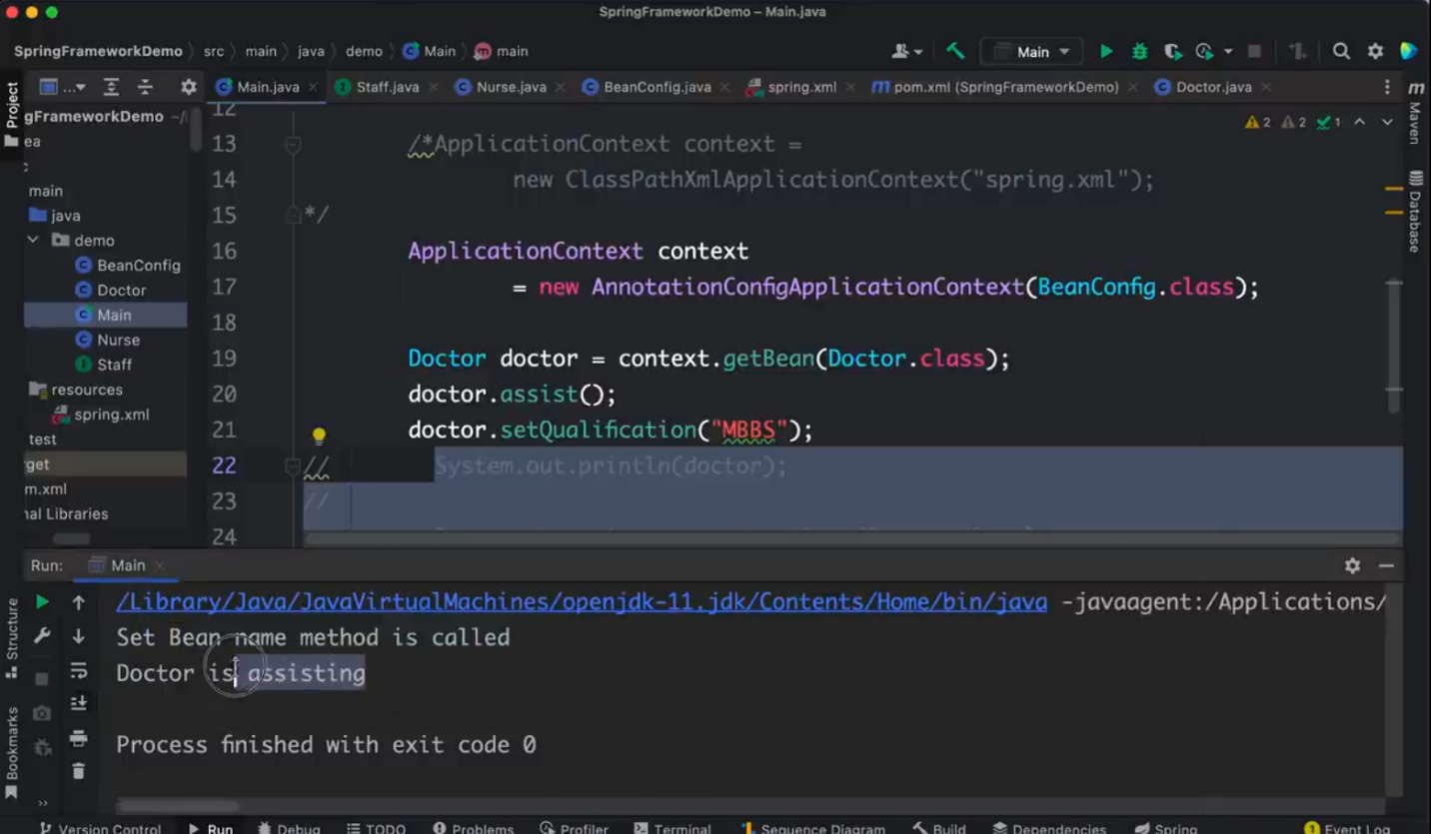

You can see Set Bean method is called before creating the object.

You can also use annotations

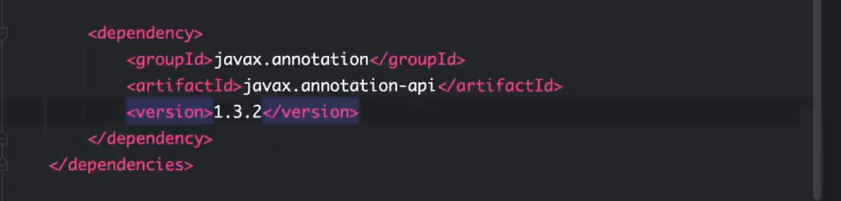

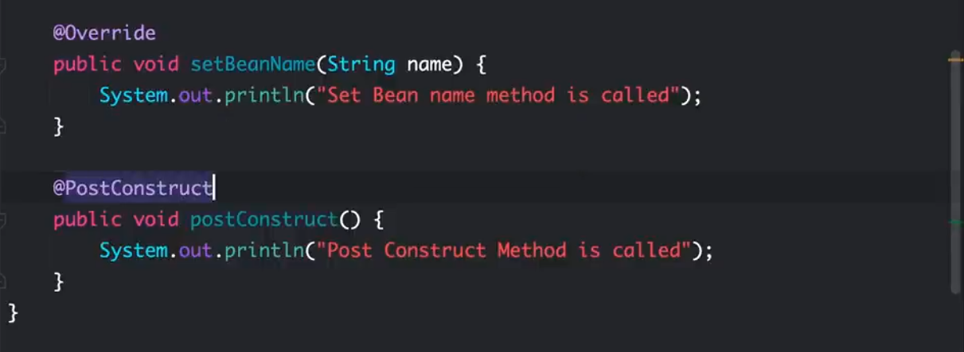

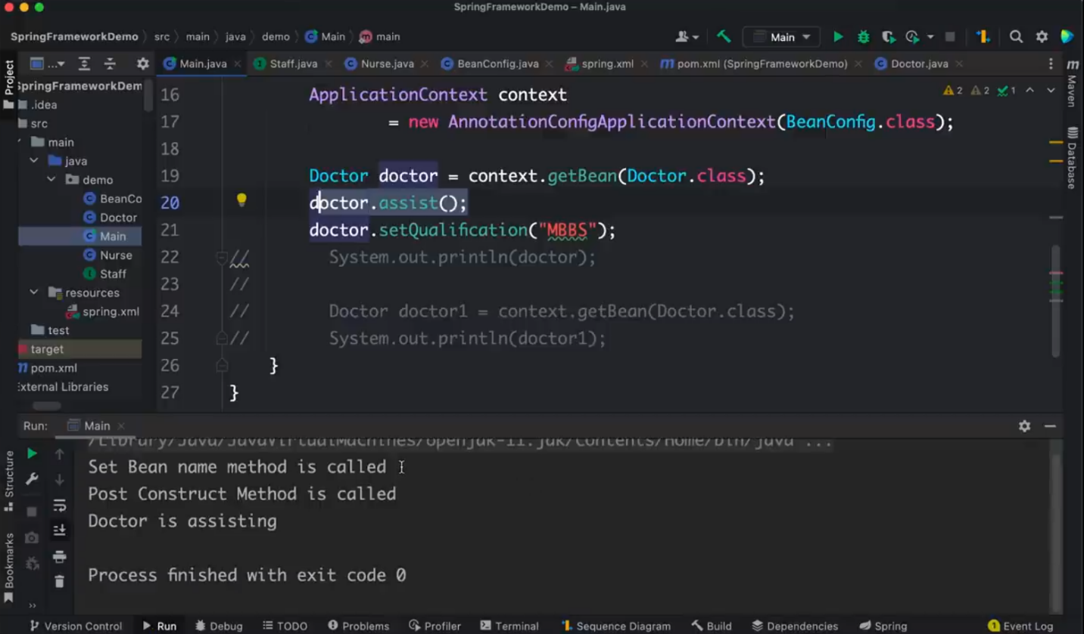

**Spring Aspect Oriented Programming (AOP)**

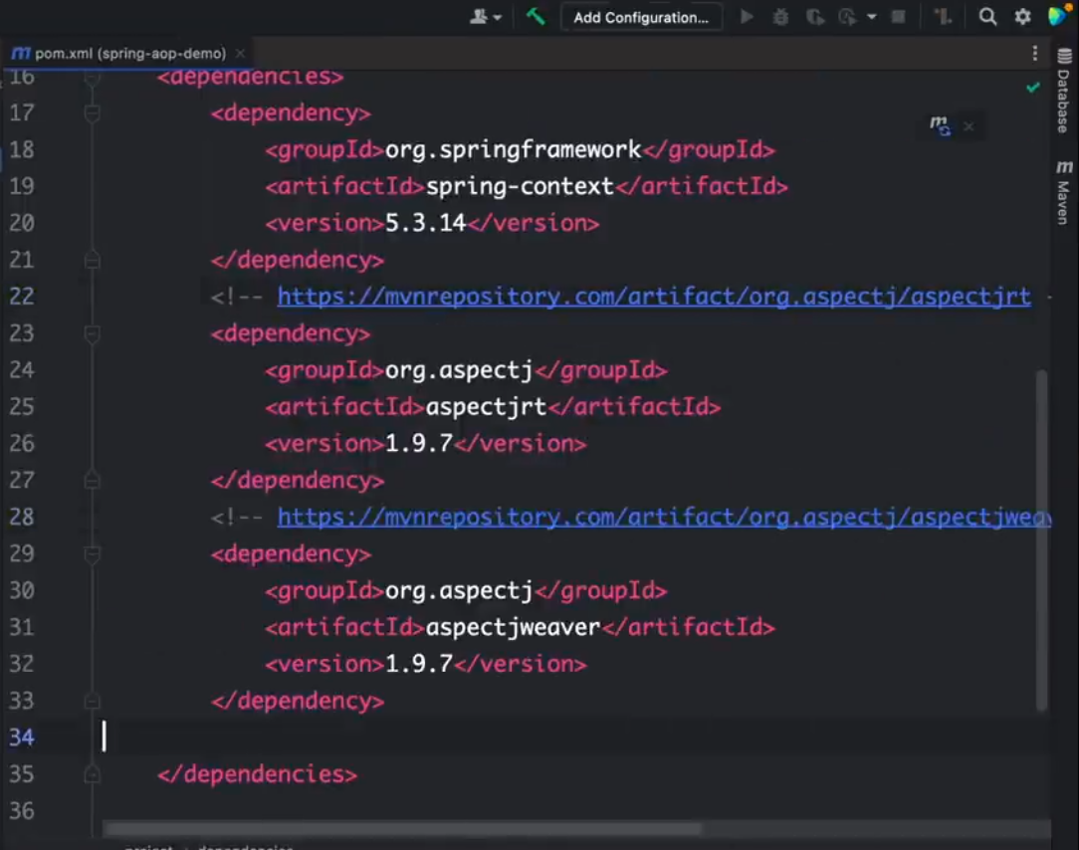

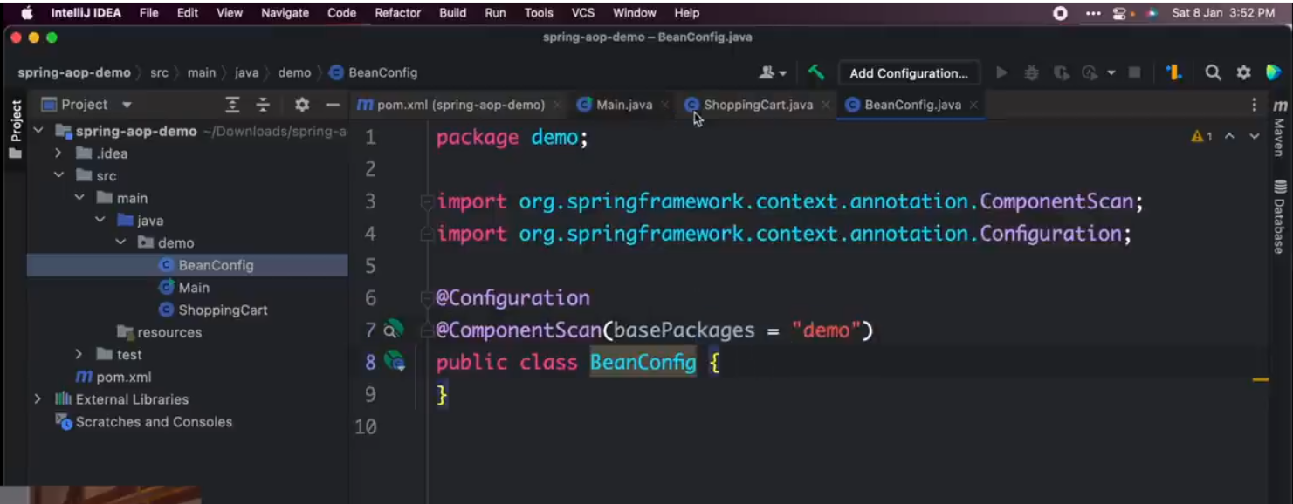

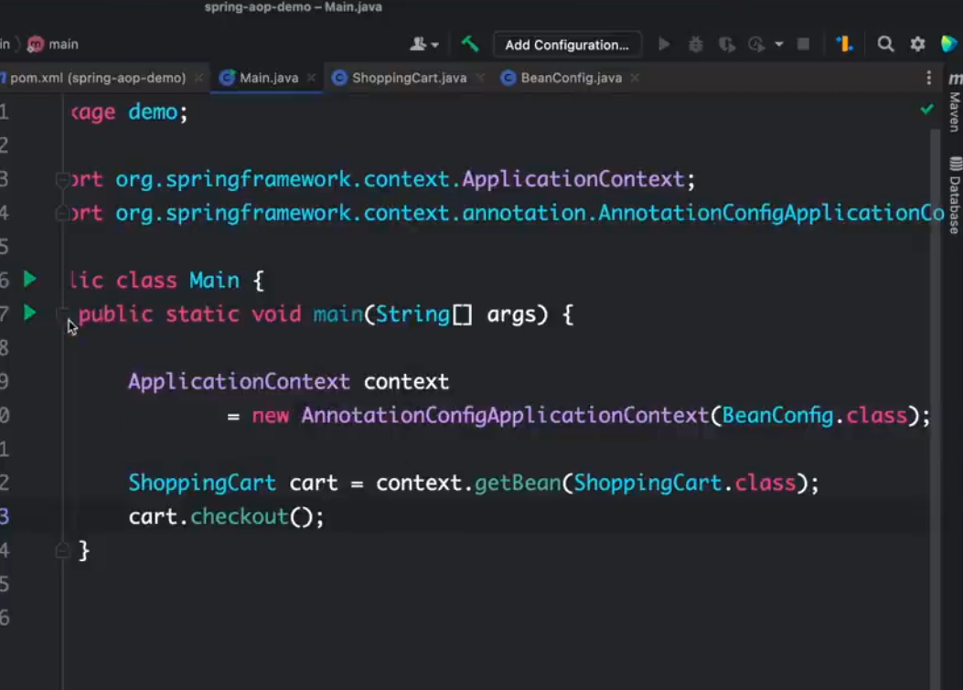

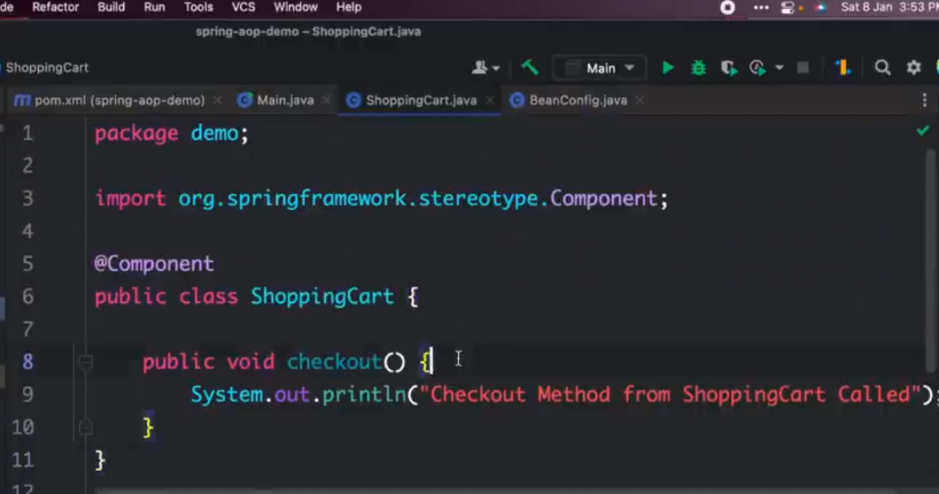

General things to be doing when accessing a shopping cart / crosscutting concerns also known as aspects.

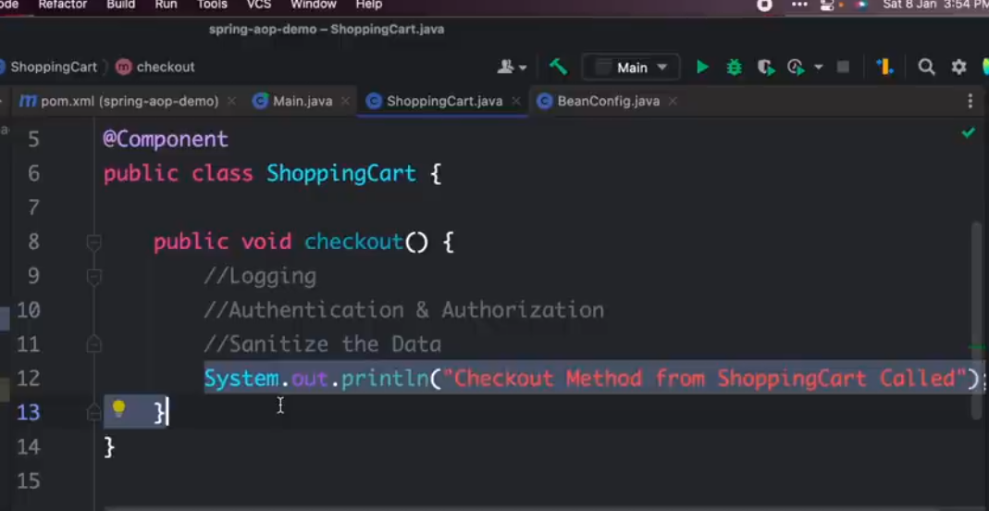

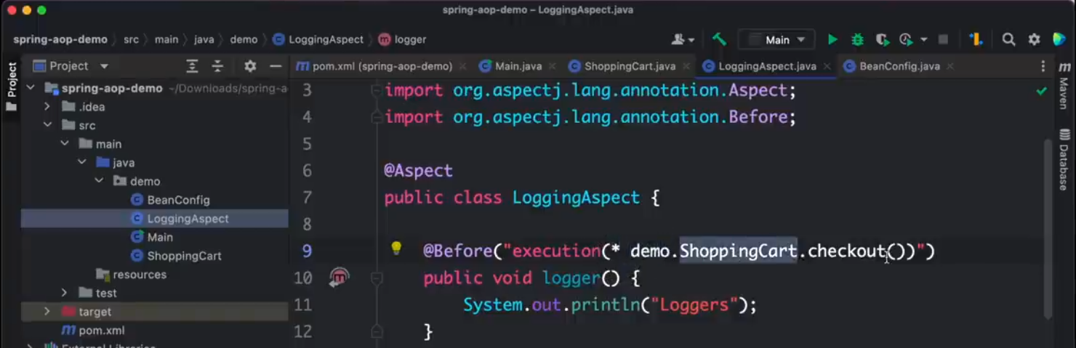

Before calling the checkout method in the ShoppingCart class, first execute the logger method.

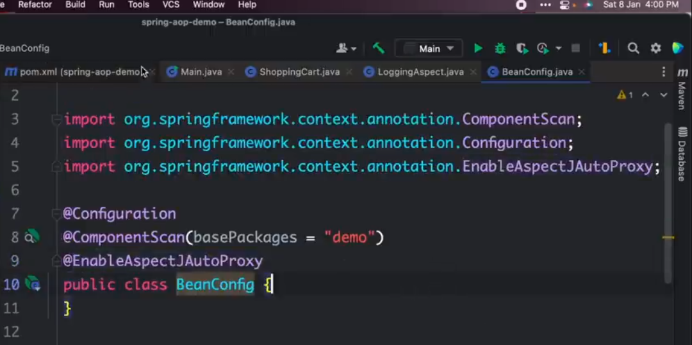

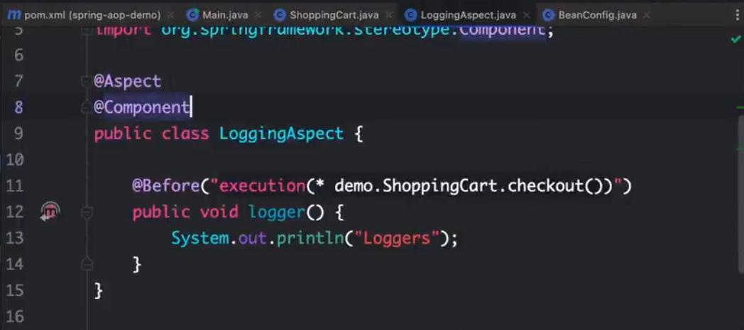

Make sure to define the Component on the LoggingAspect.

Different **pointcuts** include @Before, @After, @AfterReturning

*.*.*. checkout() equivalents to => for any written type, for any package, for any class, if there is a checkout method then run it.

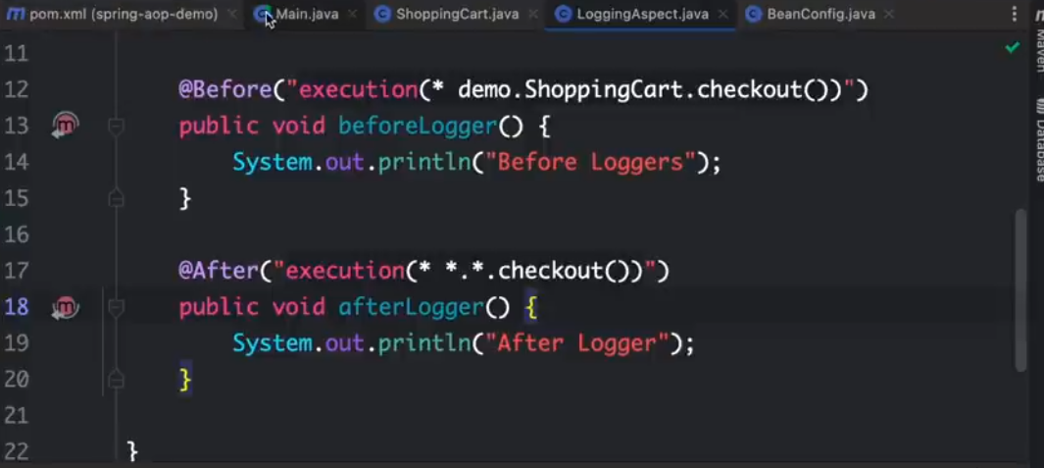

If you have input parameters;

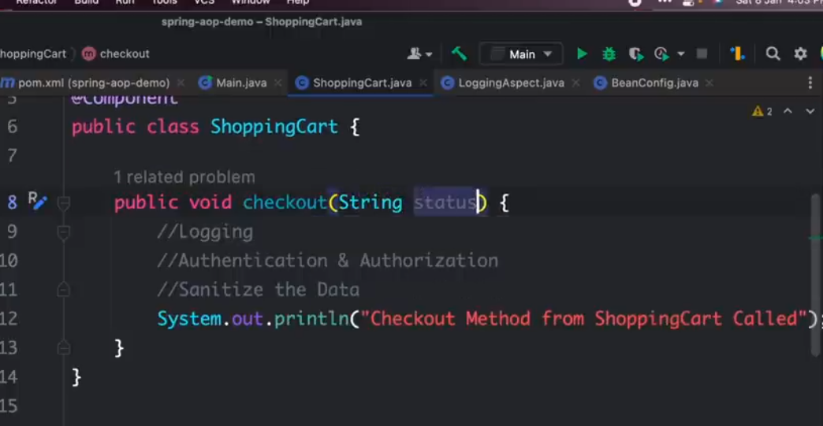

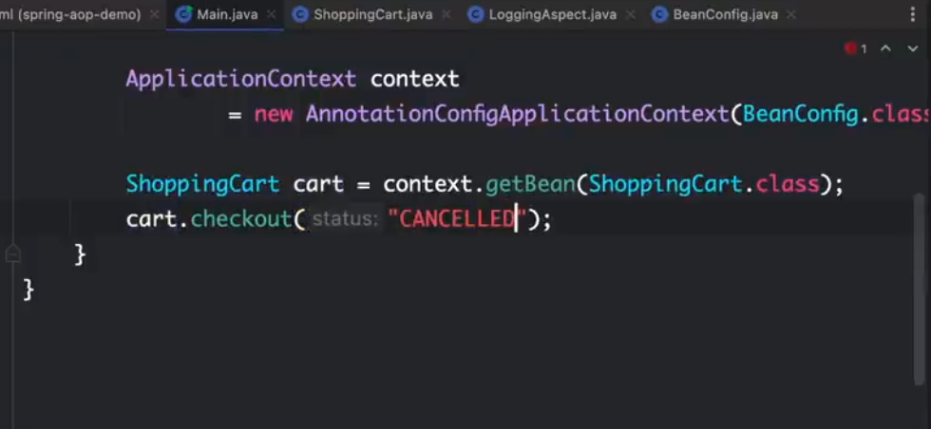

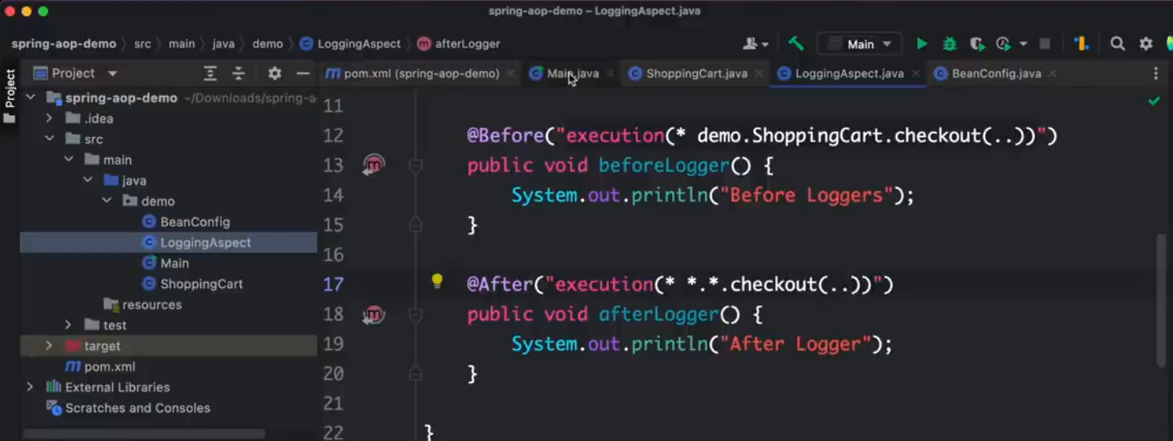

Adding an Authentication Aspect

**NOTE:** execution defines for a page which particular method you want to execute while within defines which particular type of class you want the method to execute.

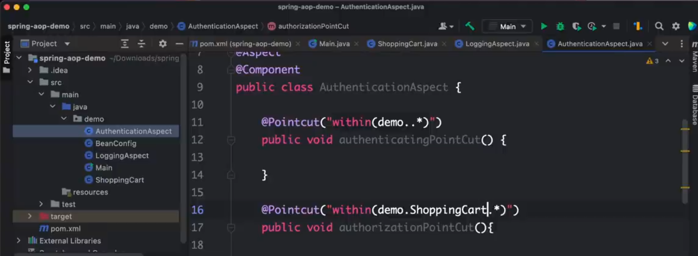

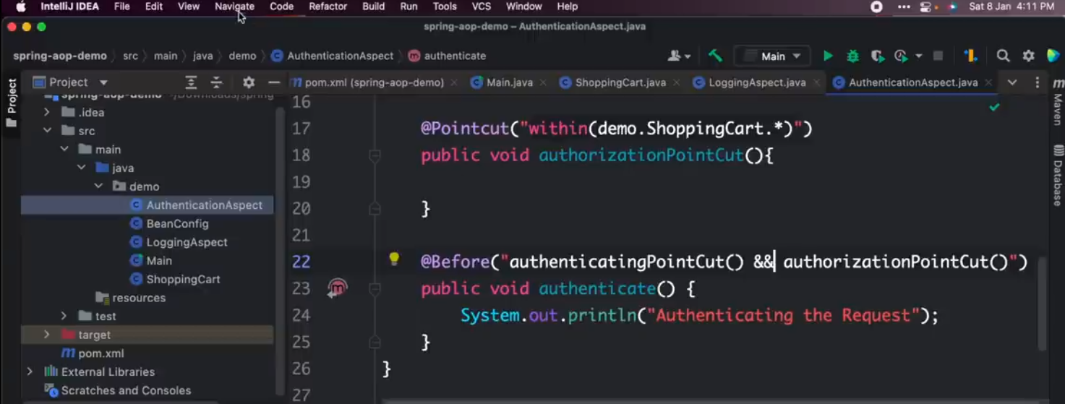

Can also use || instead of && depending on the logic. Basically means before performing the authenticatingPointCut and the authorizationPointCut I want to do authentication.

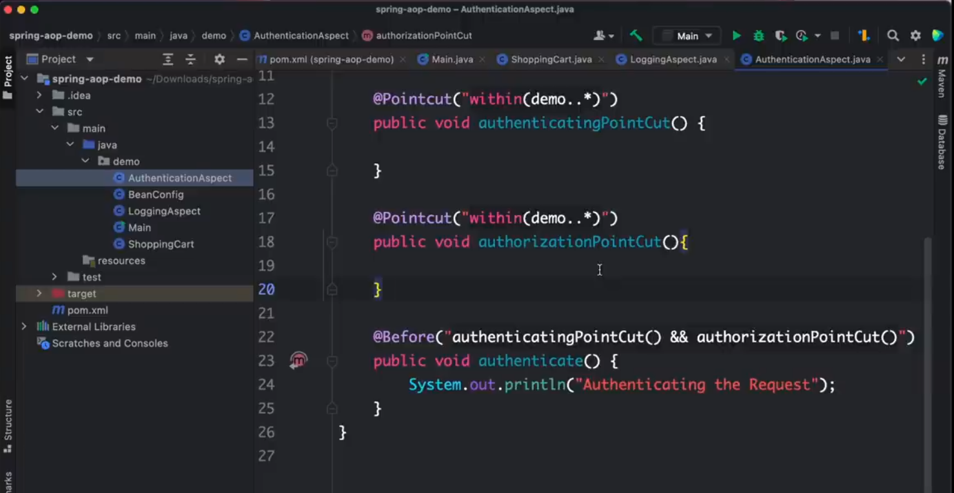

Correction on within naming for authorizationPointCut

If you want to log the argument

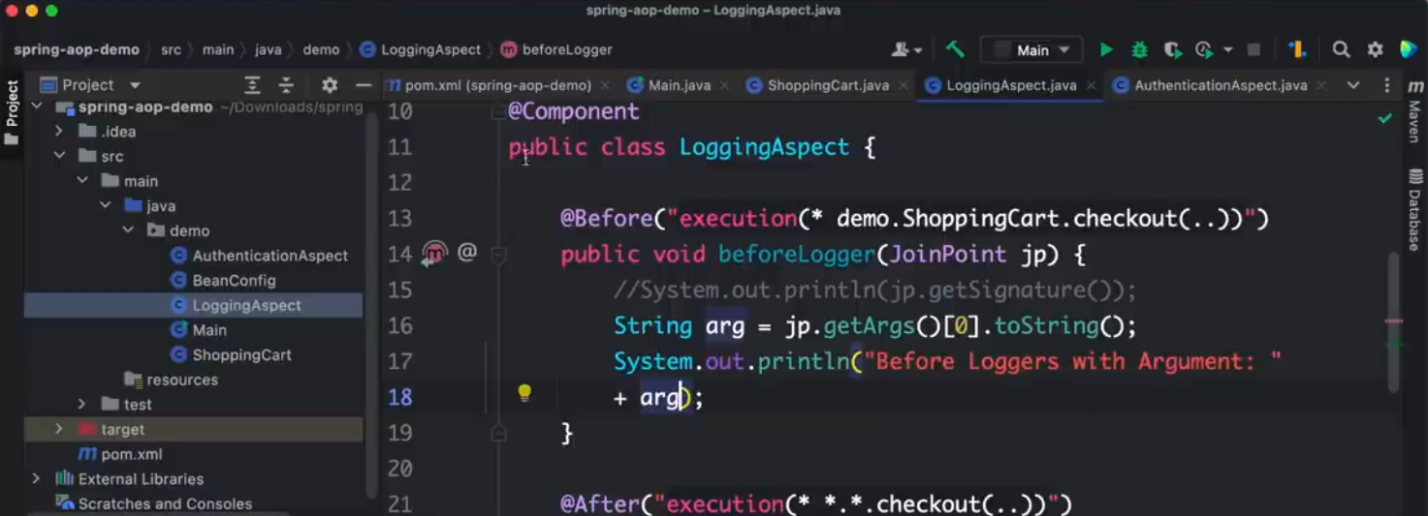

You can also access the return type

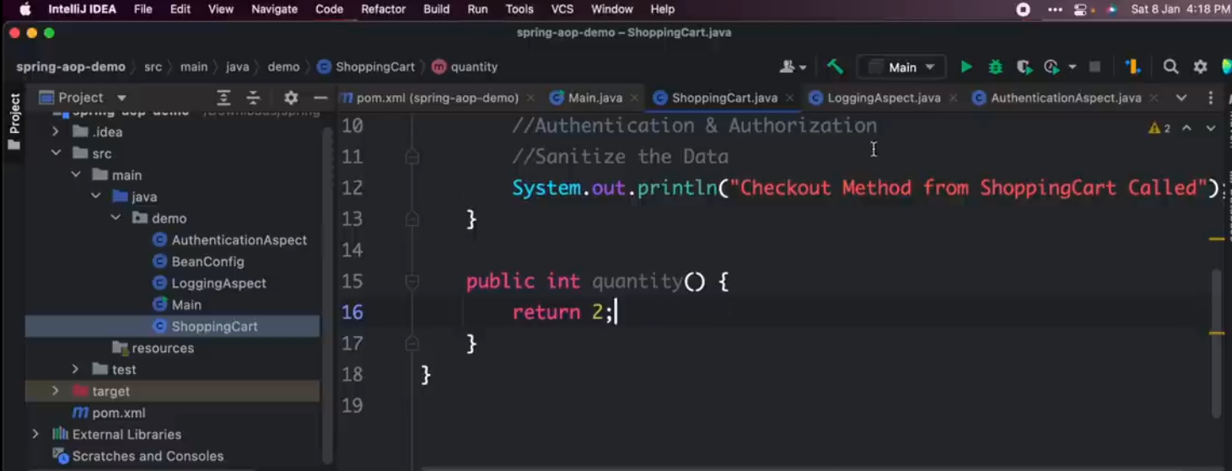

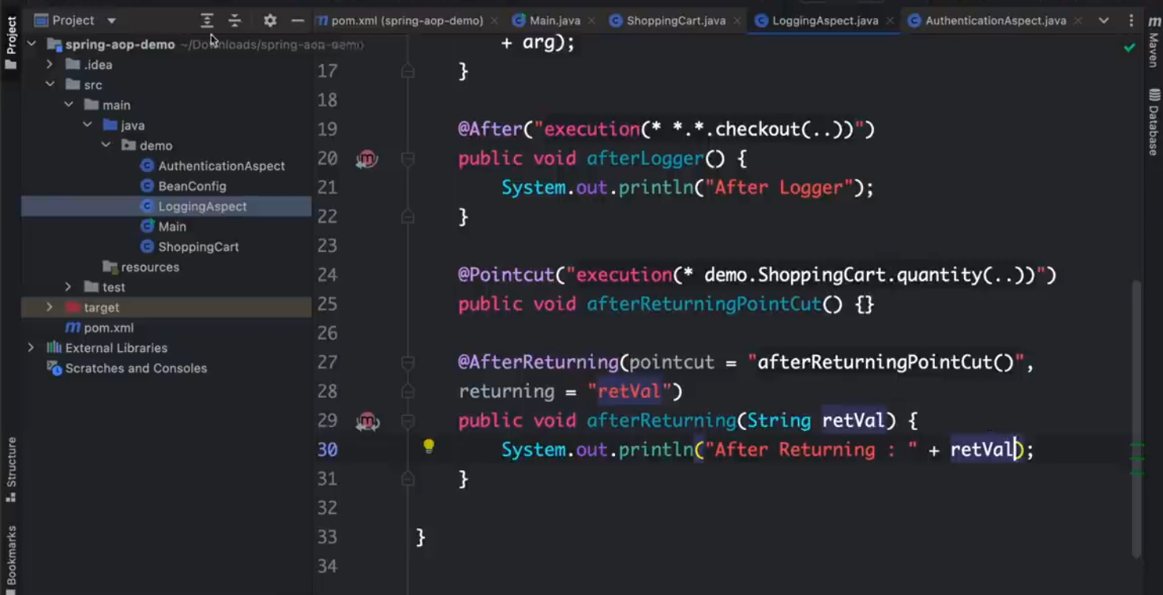

**SPRINGBOOT**

An extension of the Spring framework. Allows for RAD, managing dependencies, use of starter templates, autoconfiguration, and embedded servers.

Go to start.spring.io to create a SpringBoot application.

Download Spring Web and H2 Database

<https://start.spring.io/#!type=maven-project&language=java&platformVersion=3.2.0&packaging=jar&jvmVersion=17&groupId=com.emmakatwebaze&artifactId=SpringBoot-practice&name=SpringBoot-practice&description=Demo%20project%20for%20Spring%20Boot&packageName=com.emmakatwebaze.SpringBoot-practice&dependencies=web,h2,devtools,data-jpa,validation,lombok,sqlserver>

**IntelliJe Shortcuts**

**CTRL + ALT + O** – remove all unused imports

**ALT + Insert** – create setters, getters, toString, and constructors

Use RestController to show that a particular controller will be returning a response

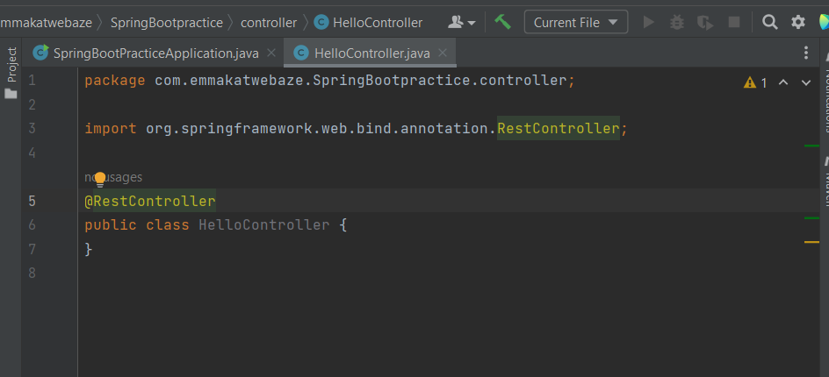

RequestMapping is used to select the url path for which to execute a particular method

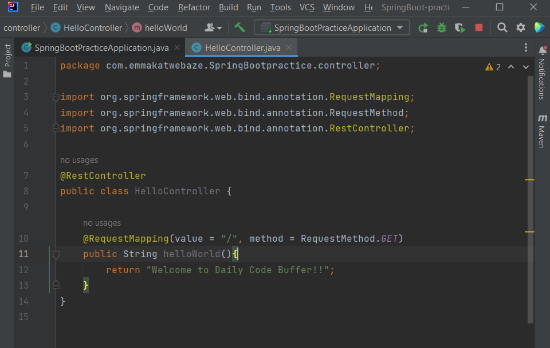

Application Properties file enables you to change the default properties of SpringBoot e.g. the server port number

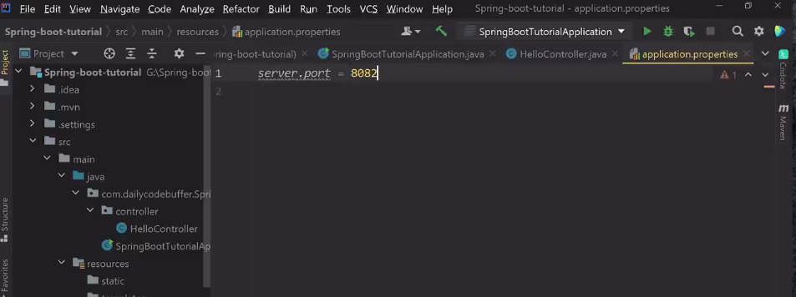

Can run a SpringBoot application using maven on the terminal using:

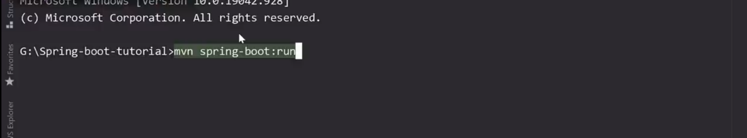

Have to add dev tools dependencies to the project

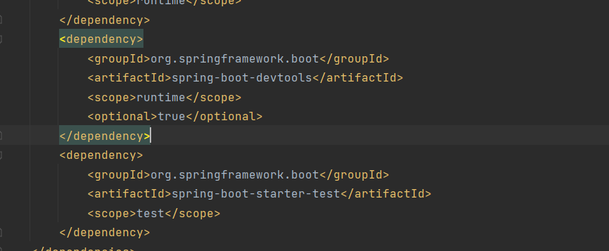

Then configure IntelliJ to support live reload since by default it doesn’t support it for older versions:

* Type CTRL + SHIFT + A and search for the Registry

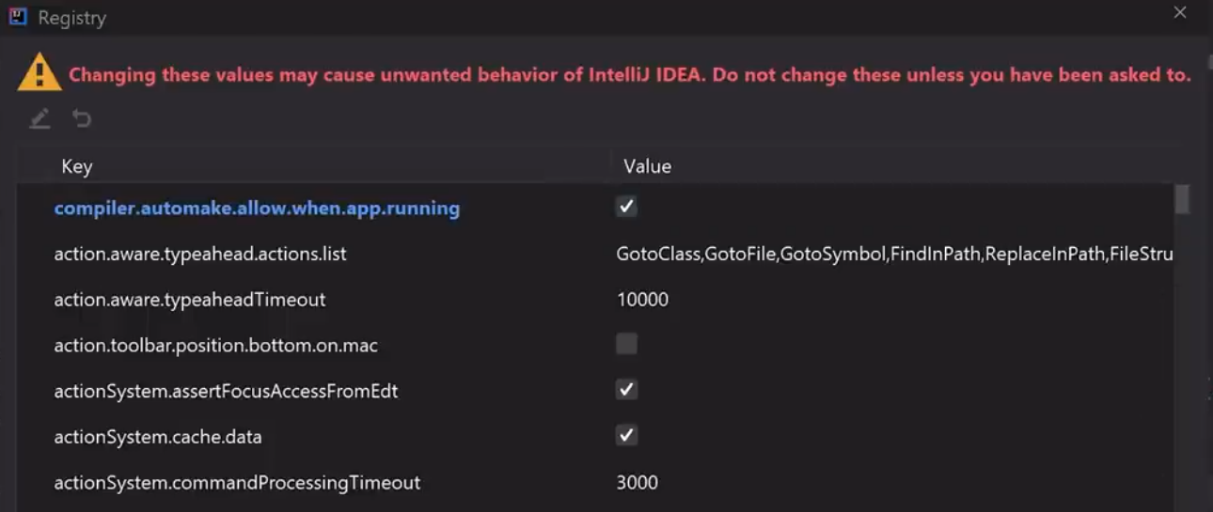

Make sure to tick “Build project automatically” under compiler settings

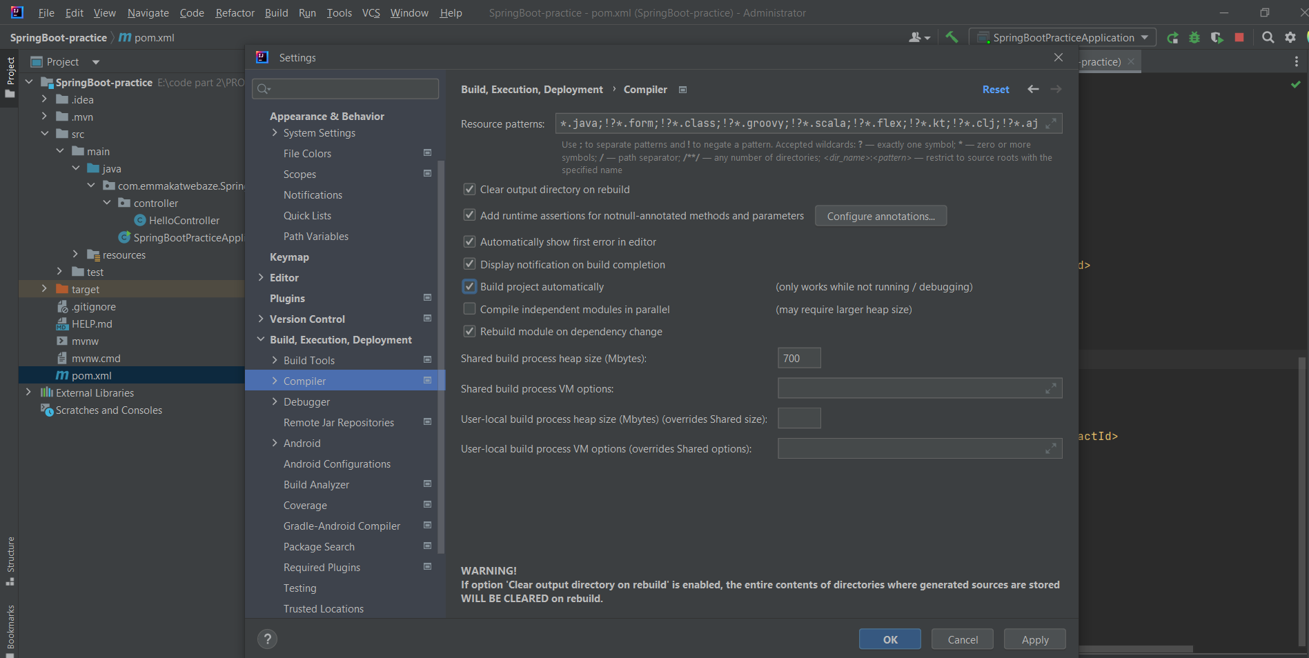

From app.diagrams.net

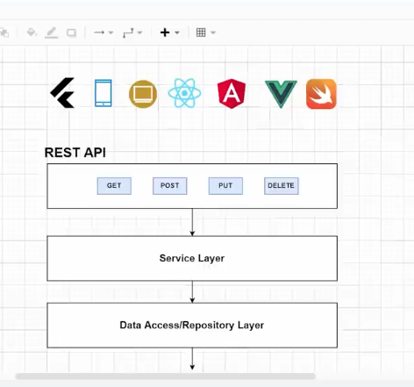

Controller layer – Just for routing processes.

Service Layer – keeps the business logic

Data Access layer – accesses the database

We use the SpringDataJPA for the Data Access layer.

Configuring the sql database for H2 and hibernate

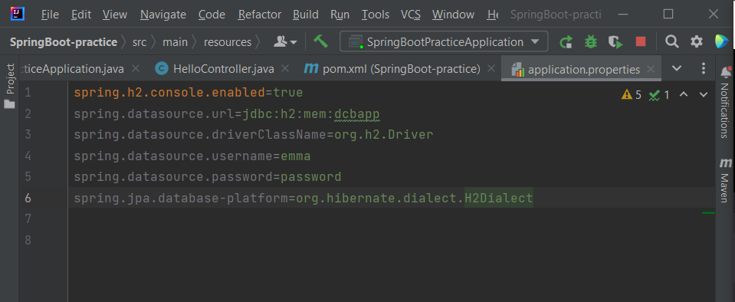

Go to localhost:8080/h2-console to access your database console

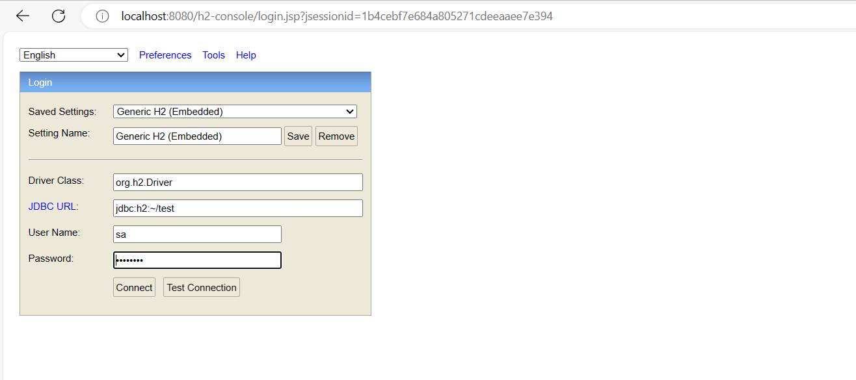

Make sure to change the parameters to match exactly what was placed in the application properties

The entity annotation makes the class able to interact with the database. The @Id and @GeneratedValue are used to create a primary key automatically for each instance of a department

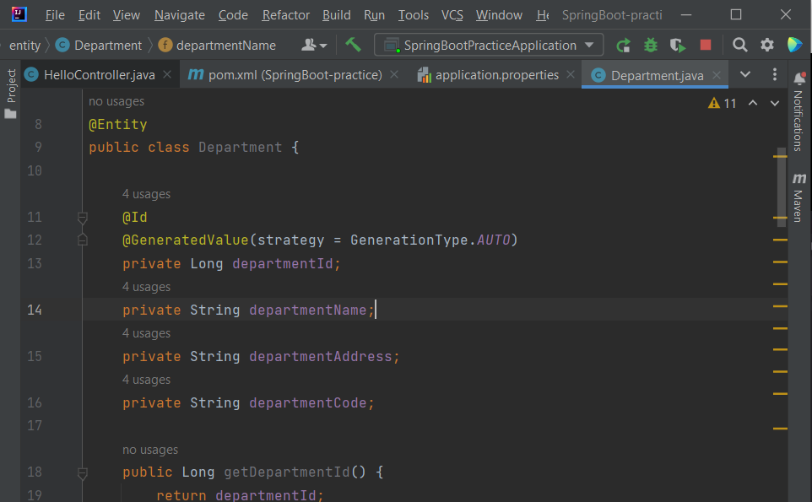

JpaRepository provides us with method to easily interact with a database. With JpaRepository you have to parse your entity as well your primary key type.

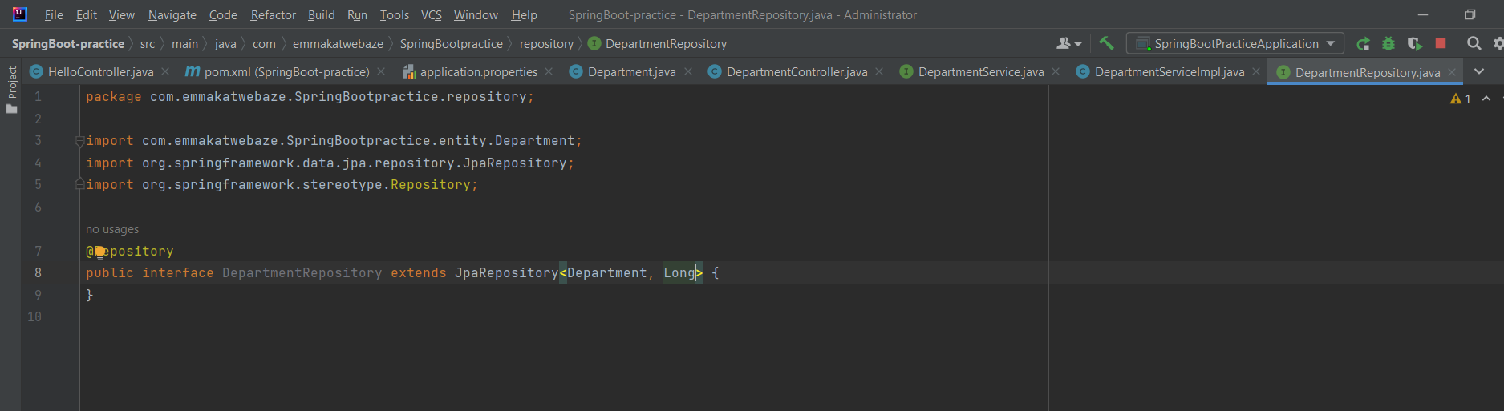

NOTE: By adding the different annotations of @Repository, @Service or @RestController we have automatically added @Component hence SpringBoot already has the different classes mapped out in the entire application and has created instances for them.

The @RequestBody annotation allows you to take an entire JSON object from the return body and convert it to your desired type.

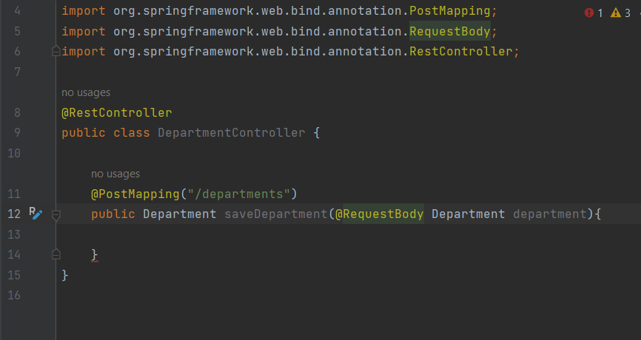

@Autowired tells SpringBoot to use it’s already created objects and attach that particular property you’re adding.

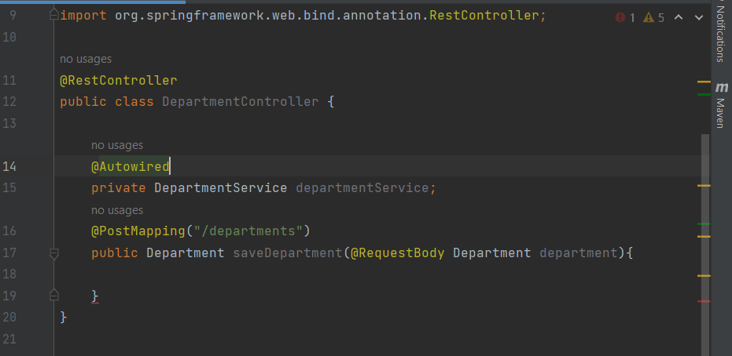

When returning a particular variable, you’ll have to use a PathVariable e.g. id

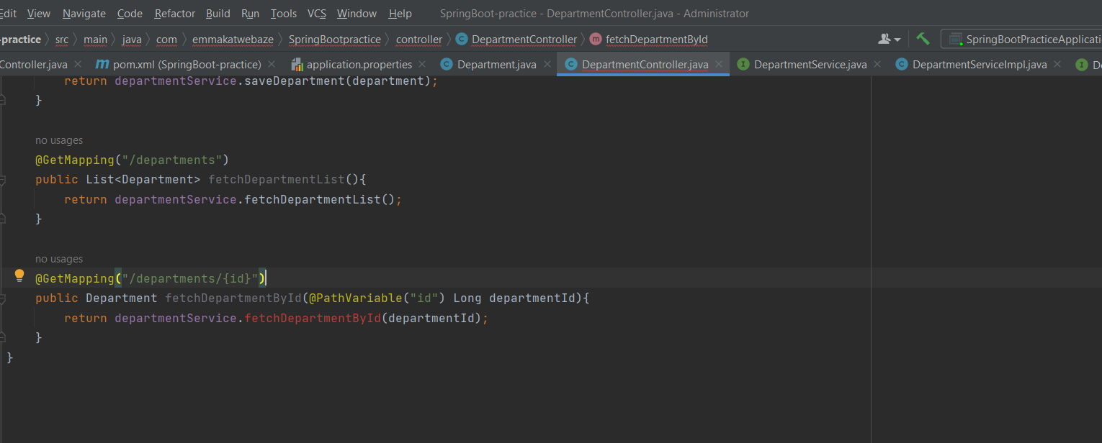

**NOTE: The pattern to creating api endpoints is:**

* Create a method in the controller class.
* Use the intellij shortcut to add the method to the service interface and make the method public in the interface.
* Go to the service implementation class and then implement all the necessary methods of the department service interface.
* Return the necessary function in that particular method using the Jpa methods provide.

When you have a method that’s not part of the Jpa repository, you have to define it yourself with a proper naming convention that follows the particular property you want to access like for this case.

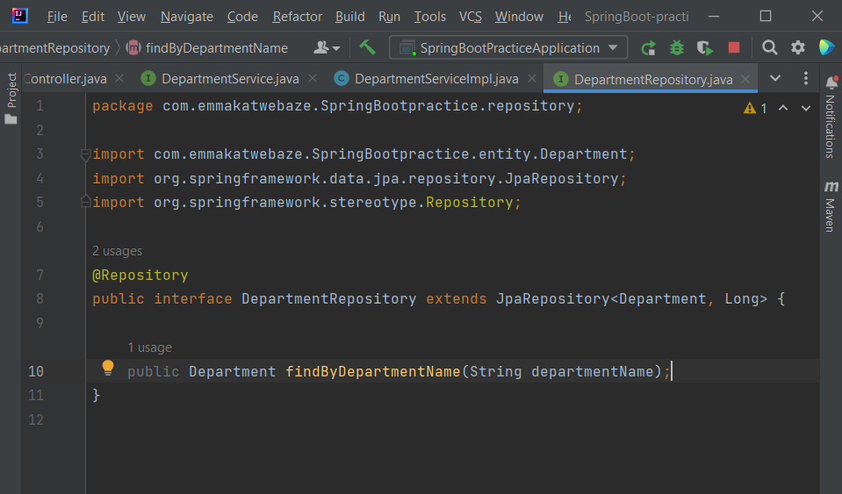

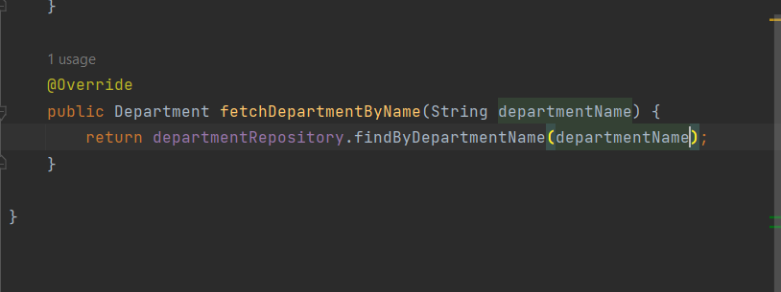

Use SpringBoot validation for validating your data easily

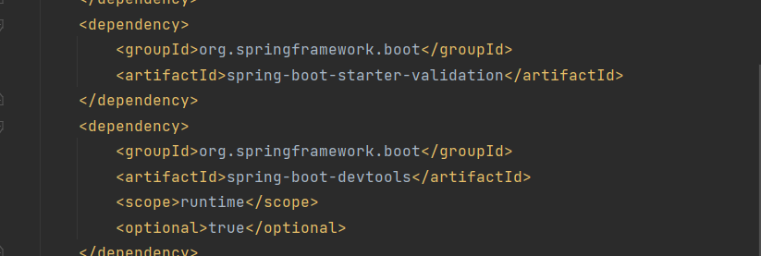

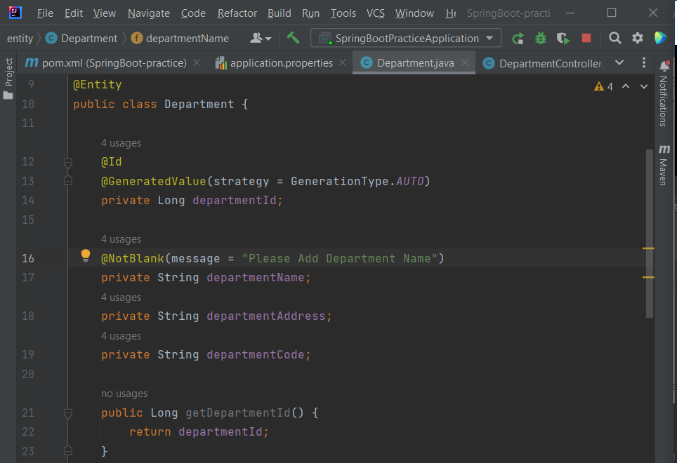

Adding @NotBlank annotation makes sure that the departmentName must be included

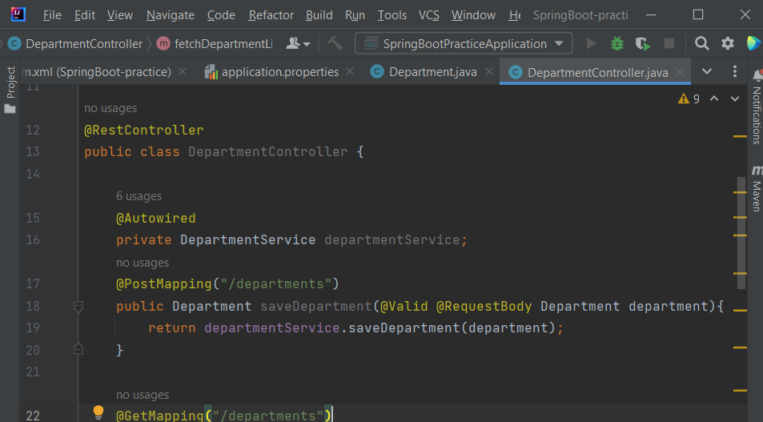

The @Valid annotation will make sure that the saveDepartment method must pass validation as specified by our different validation annotations.

You can add logging information using the Logger class from sl4j

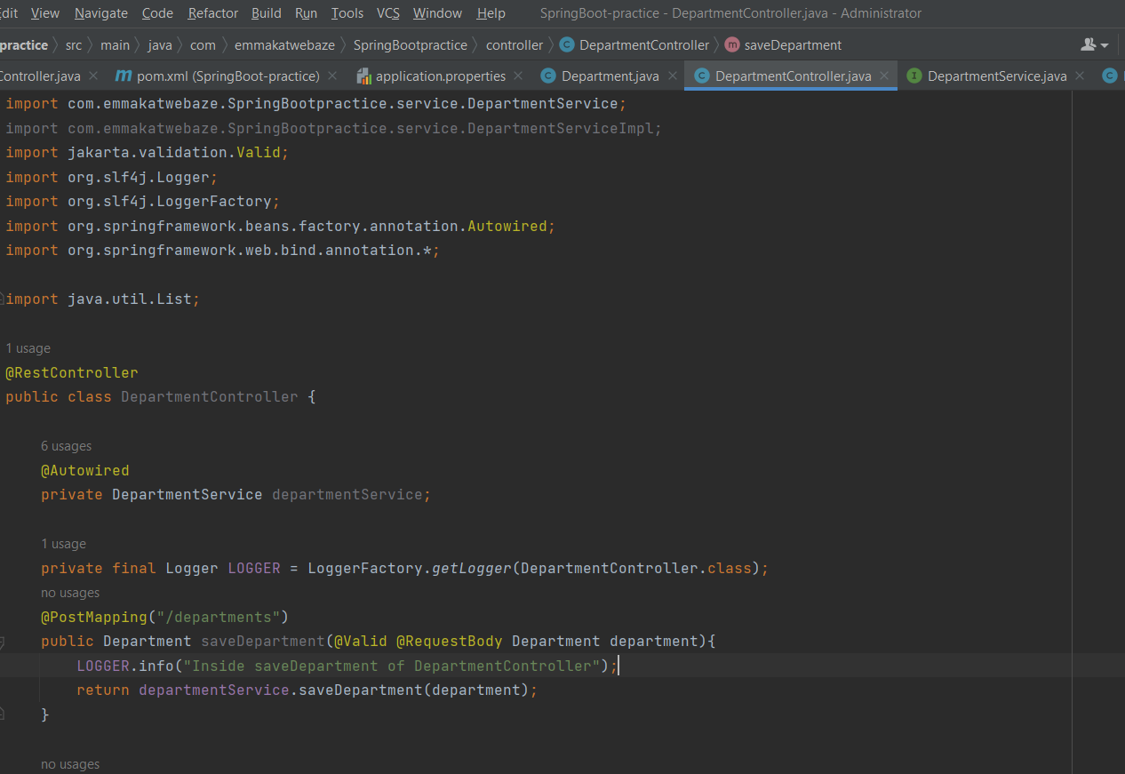

Lombok helps us to reduce boilerplate code like getters and setters in our application thus making it cleaner. And you also have to include it as a plugin in IntelliJ.

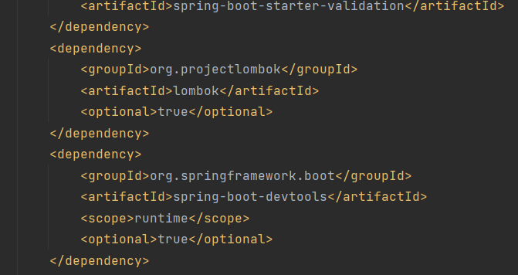

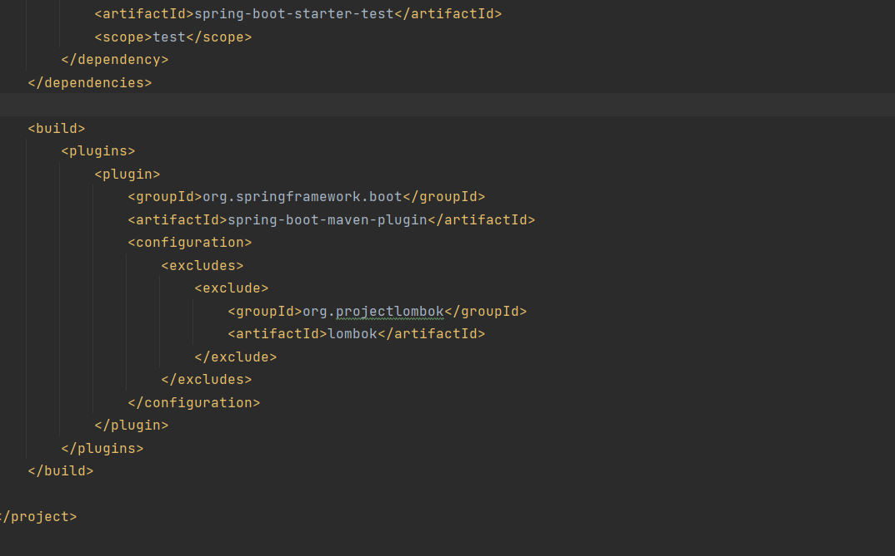

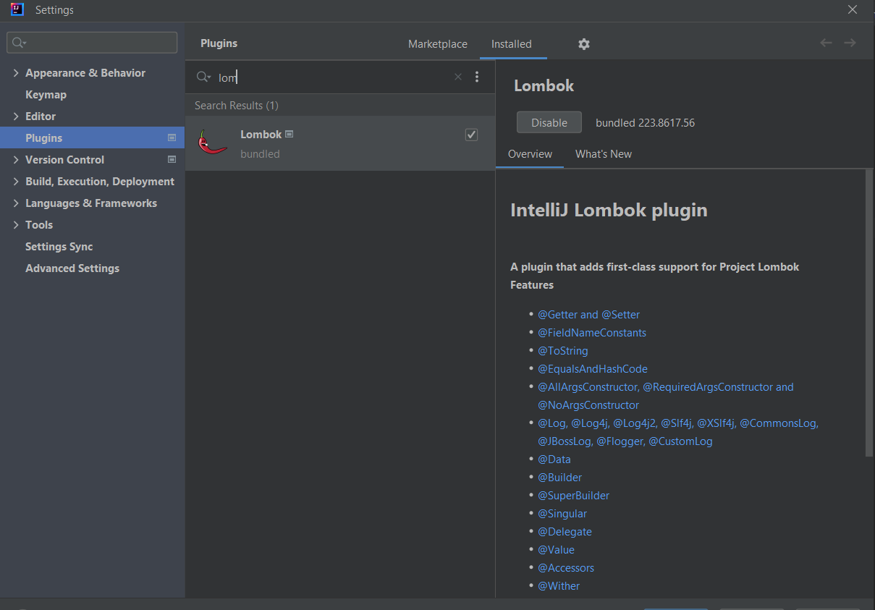

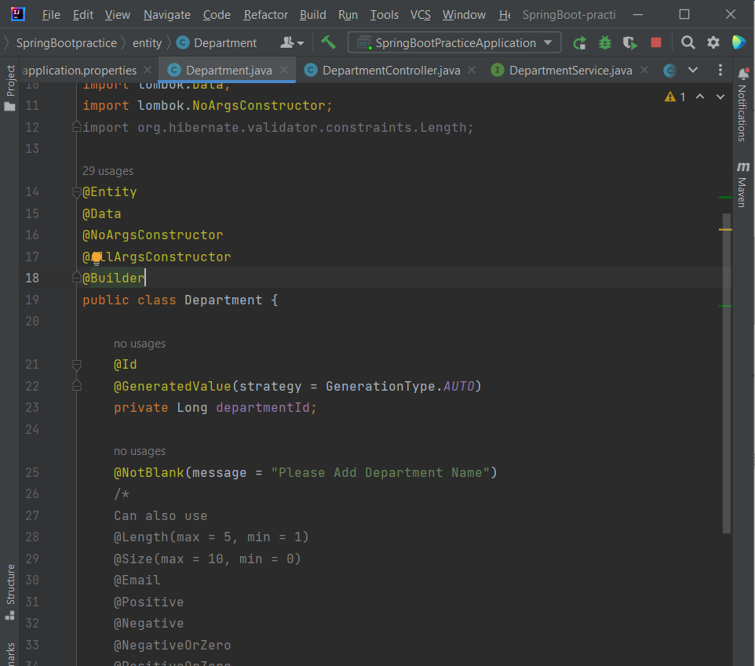

By adding @Data annotation, you use Lombok. Make sure to delete all your getters, setters and constructors.

**NOTE**: When creating exceptions first create and implement all exceptions in it’s own class, then go to the controller and throw the particular exception. Afterwards use the shortcut of ALT + ENTER to implement the exception in the appropriate places.

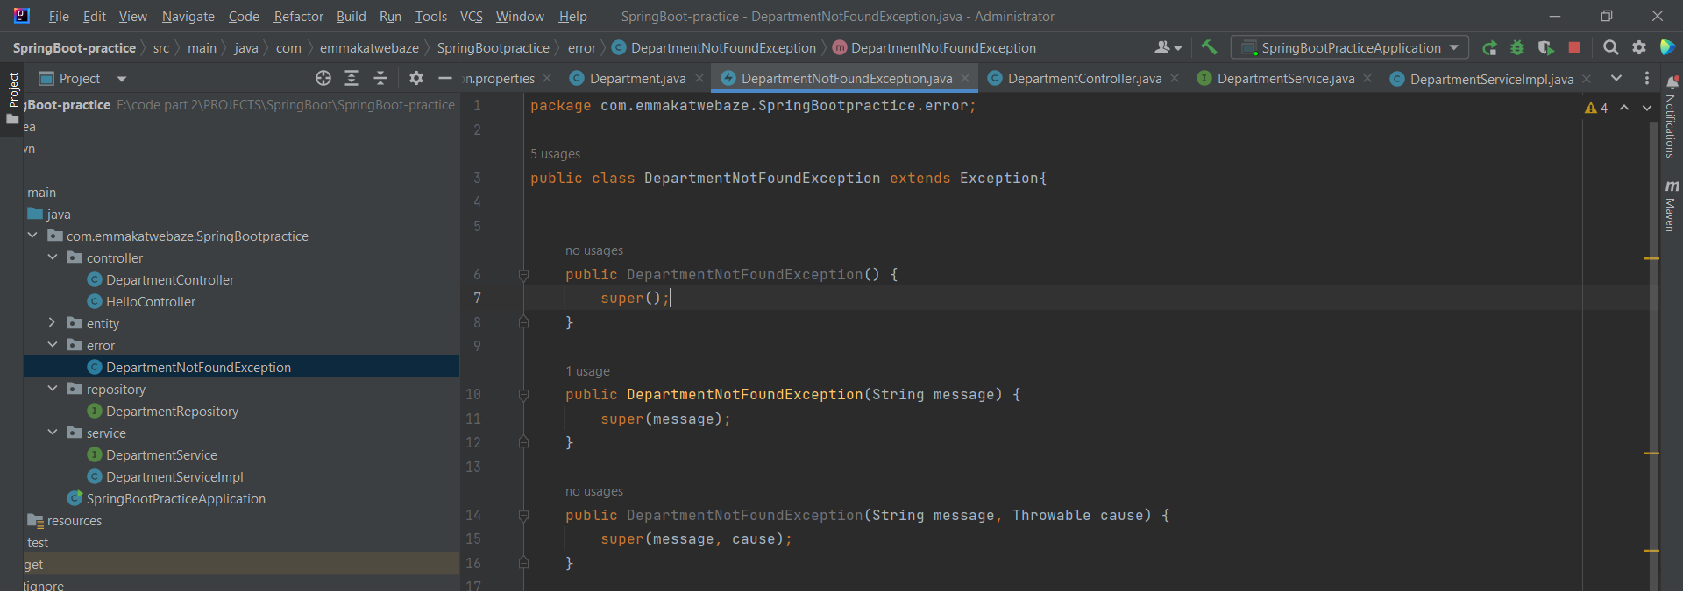

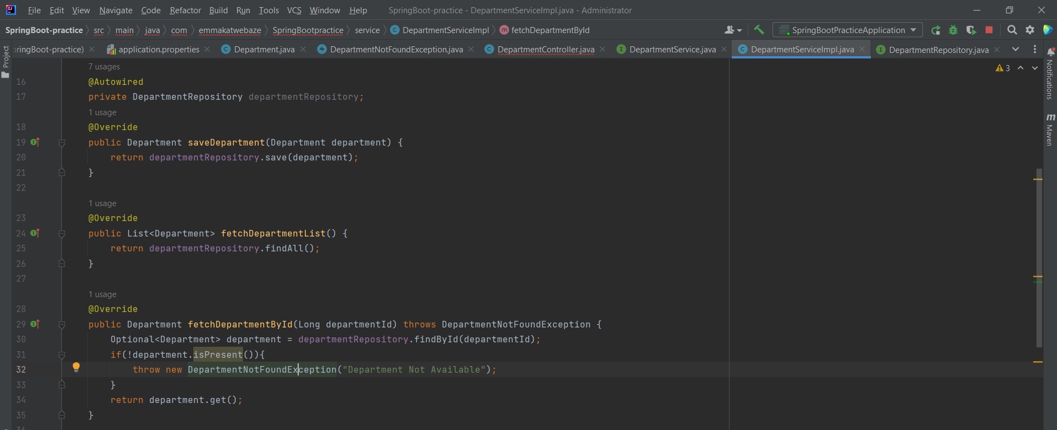

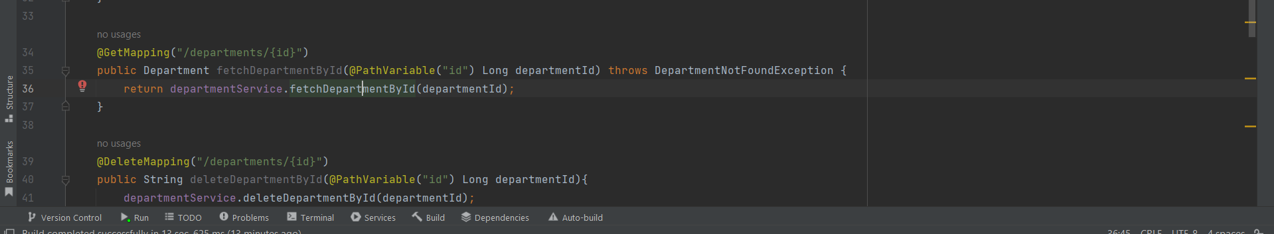

Create a class to handle particular exceptions and format them in the appropriate way.

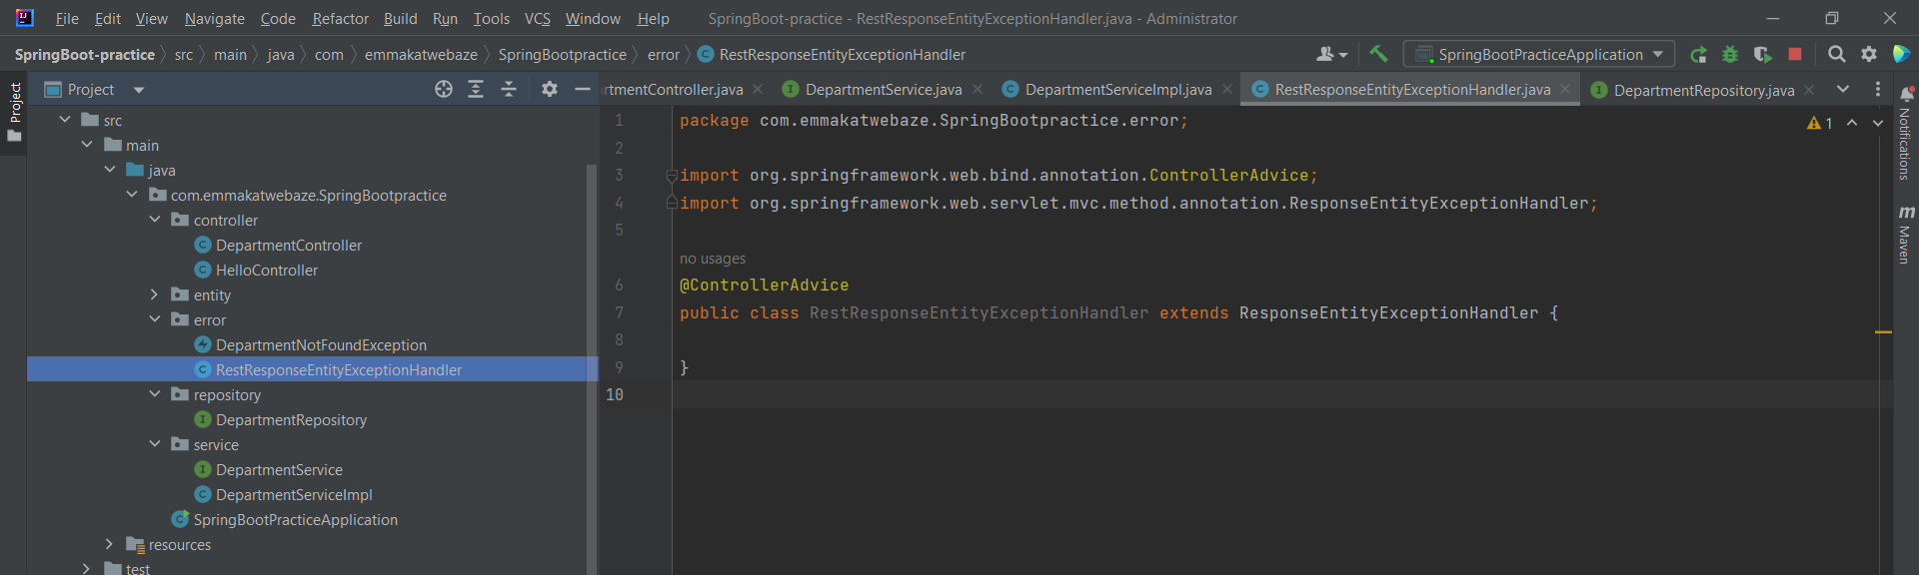

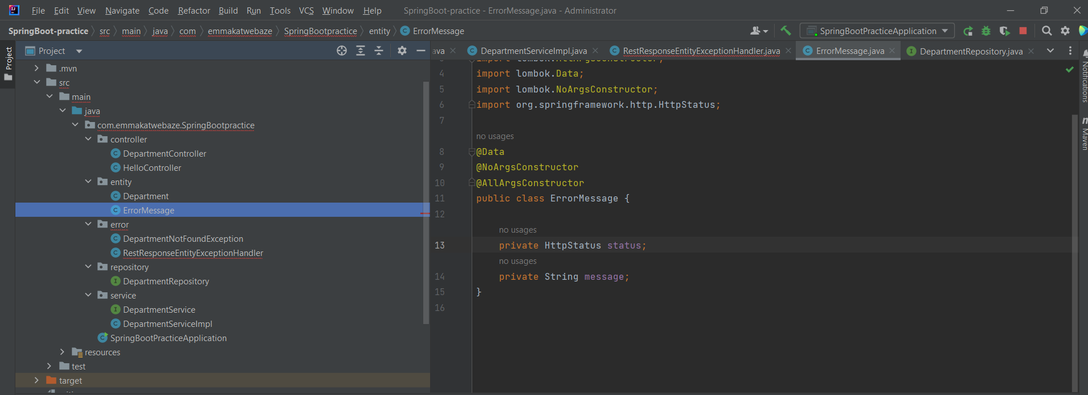

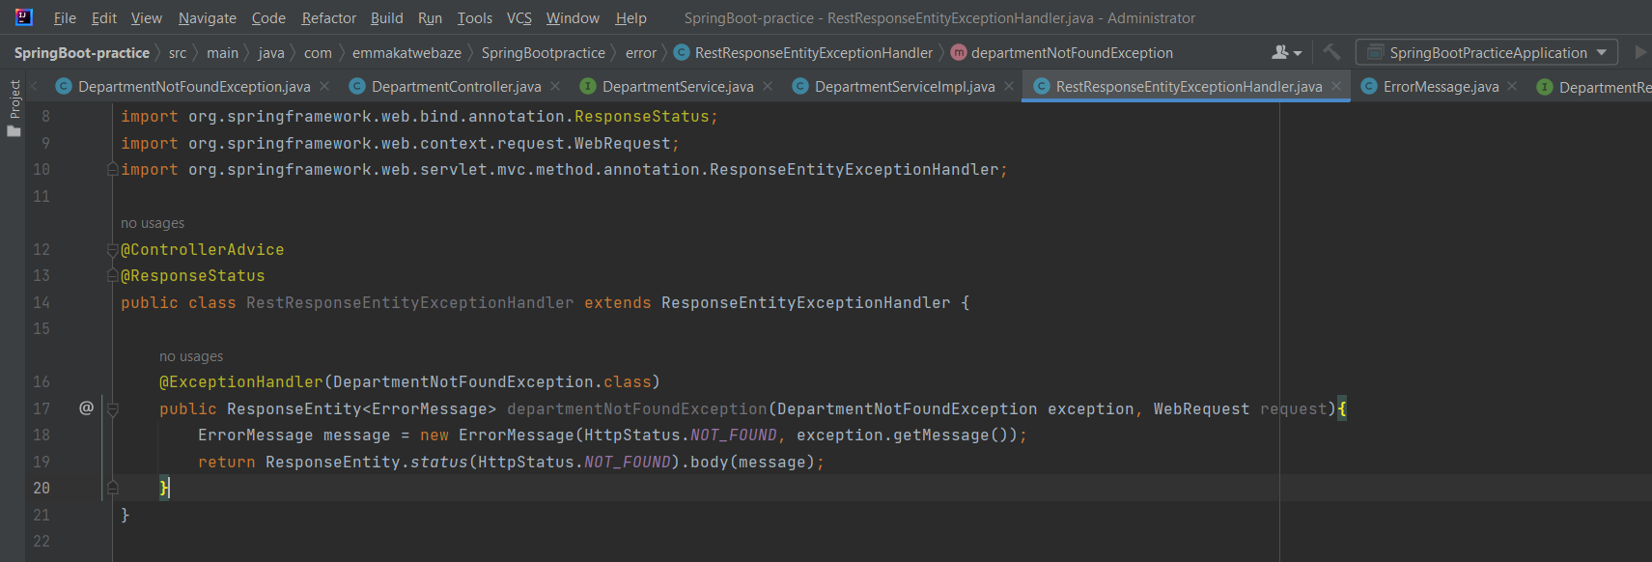

**When connecting to a mysql database, you’ll have to add mysql to the pov file as well as change the application properties.**

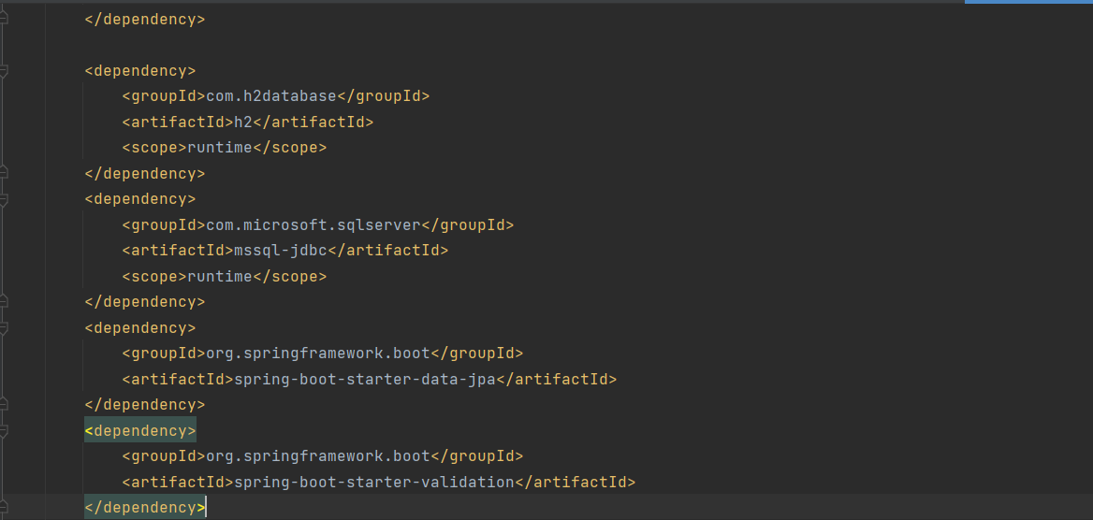

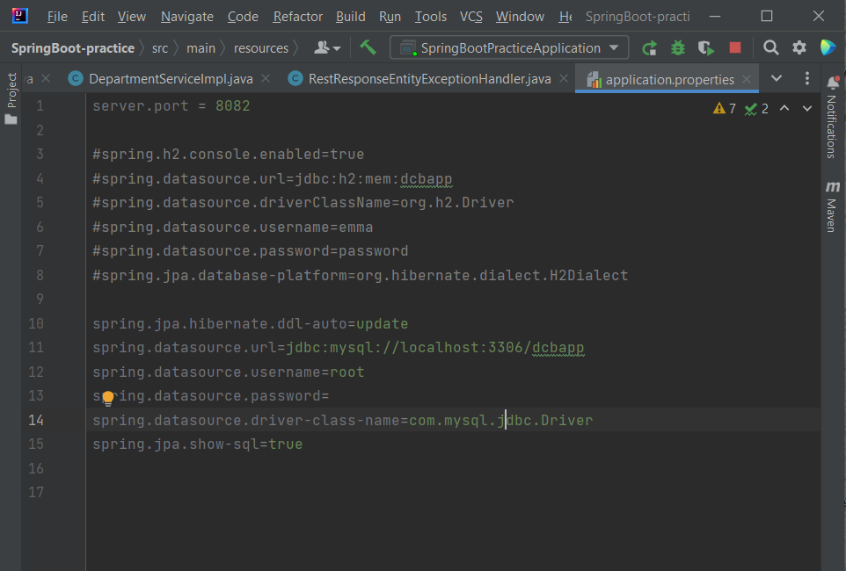

Note: There may be a need to add the mysql driver to the dependencies explicitly under the project structure dependencies.

**UNIT TESTING**

**NOTE:** With IntelliJ you can automatically generate a test case by using **ALT + Insert** on the class or interface for which you want to generate a test case.

@SpringBootTest annotation will tell SpringBoot that that is a particular test class.

1. Unit Testing the Service layer

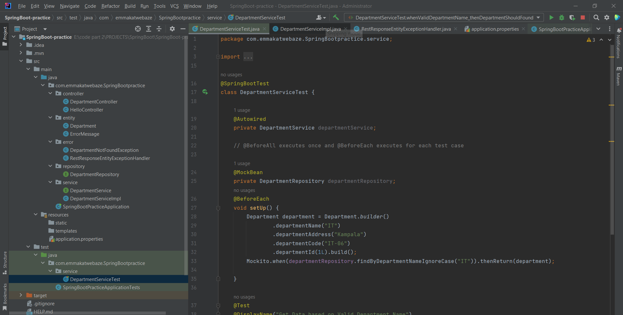

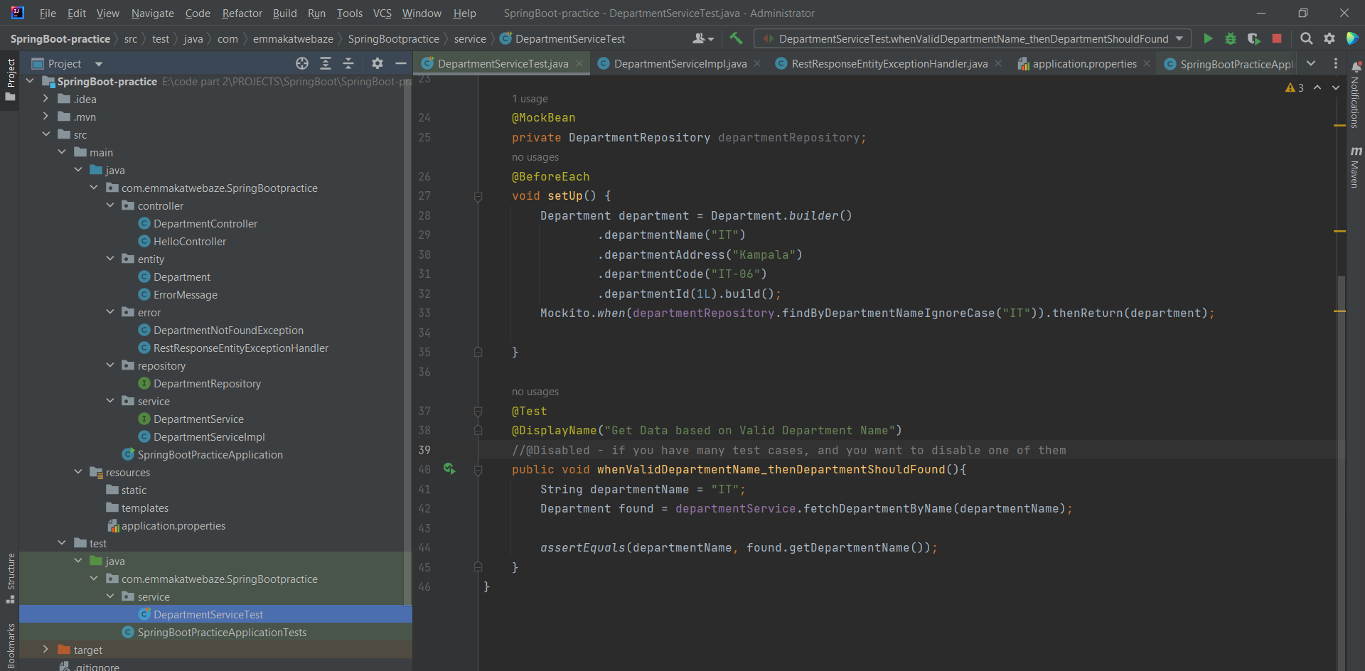

1. Unit Testing the Repository Layer

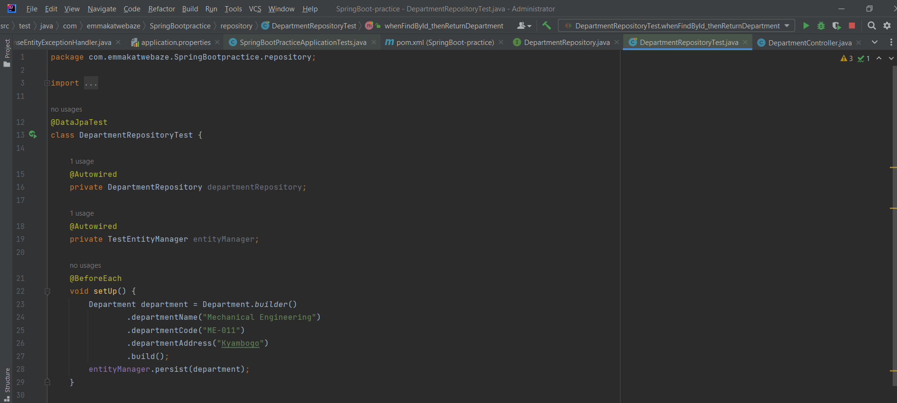

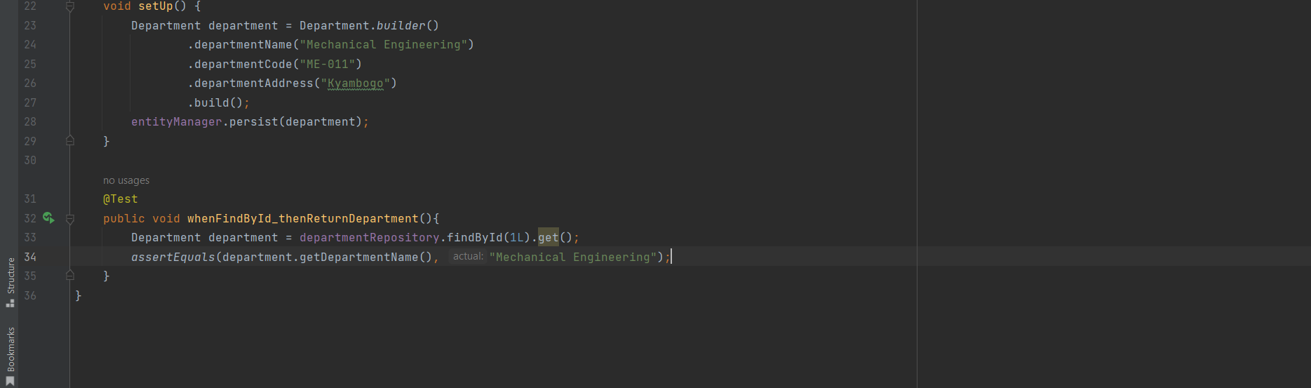

1. Unit Testing the Controller layer

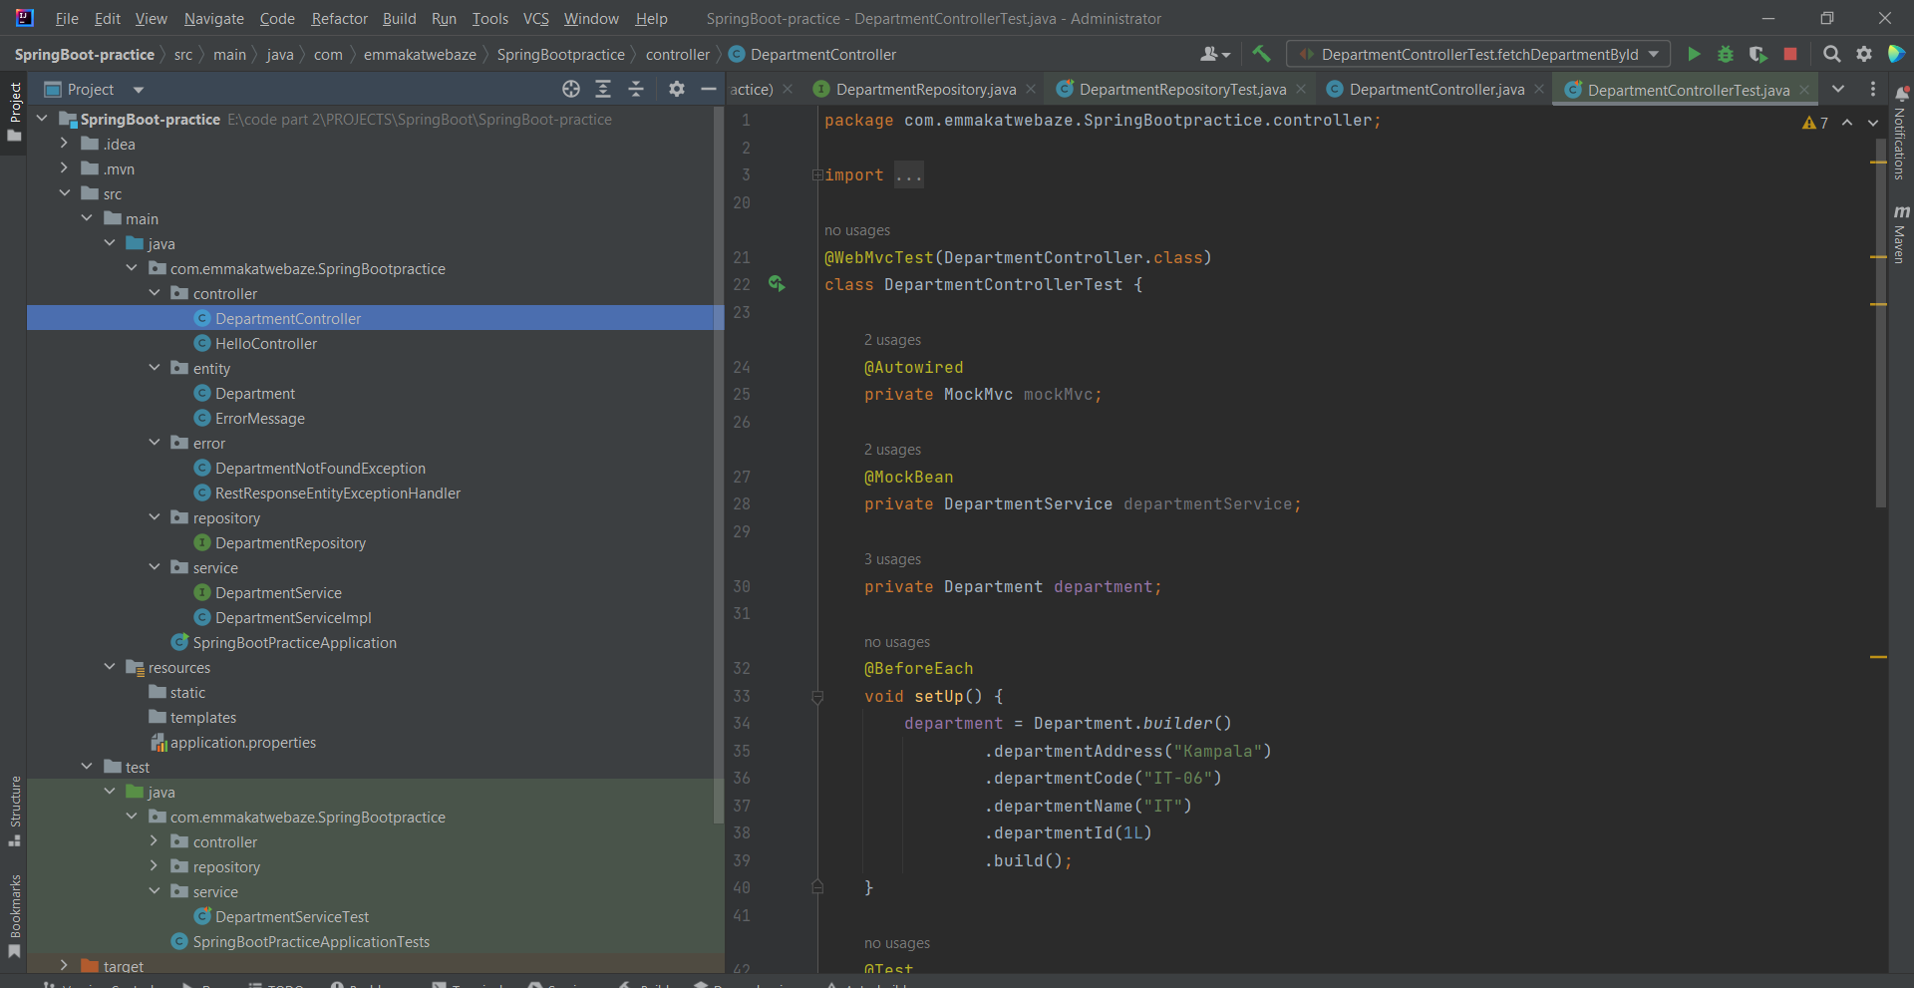

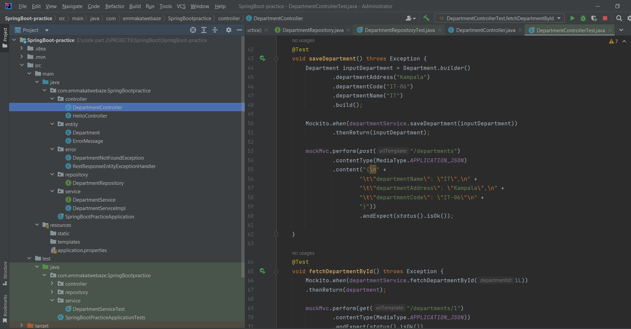

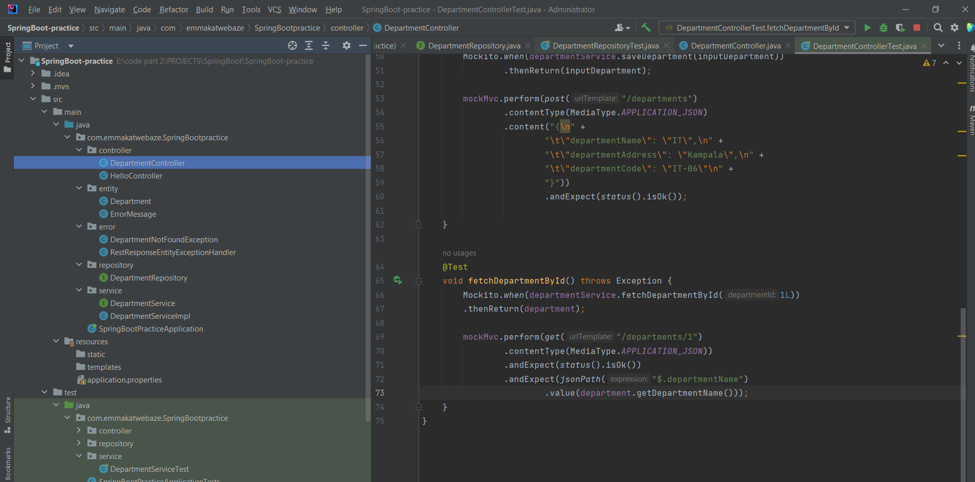

You can create and use your own config files as below:

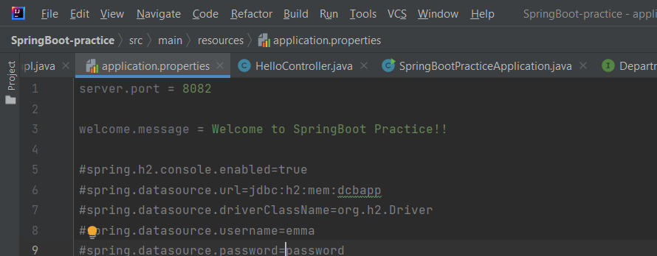

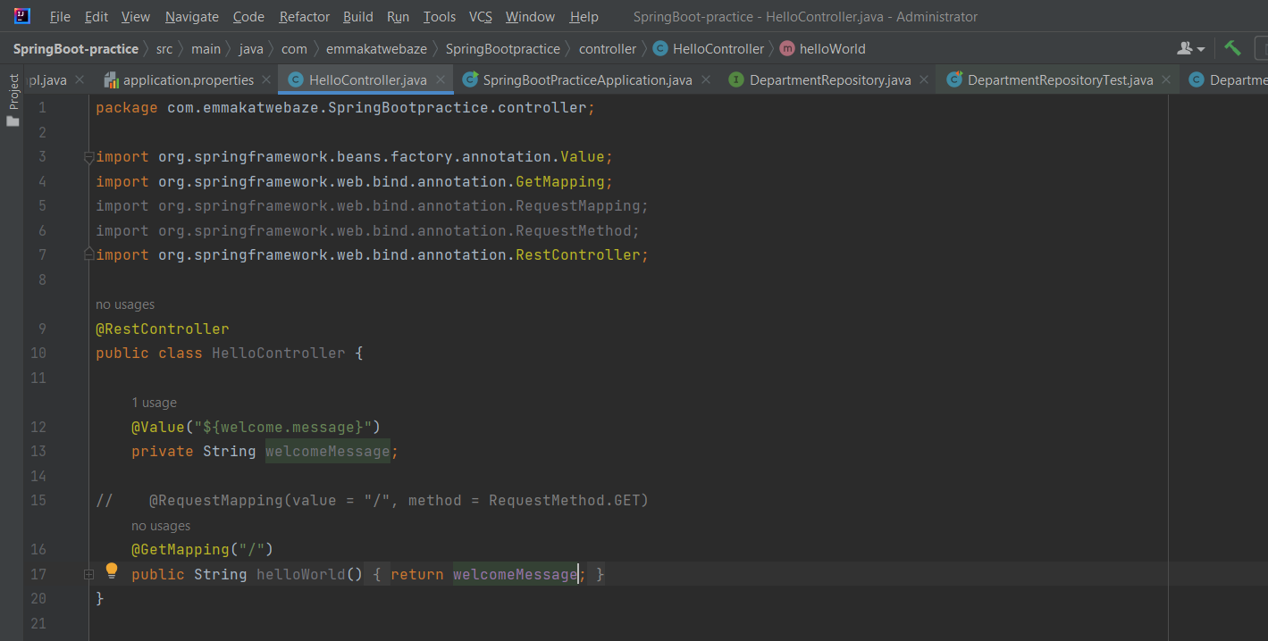

**Use properties to yaml online tool converters to convert your application properties to yaml format.**

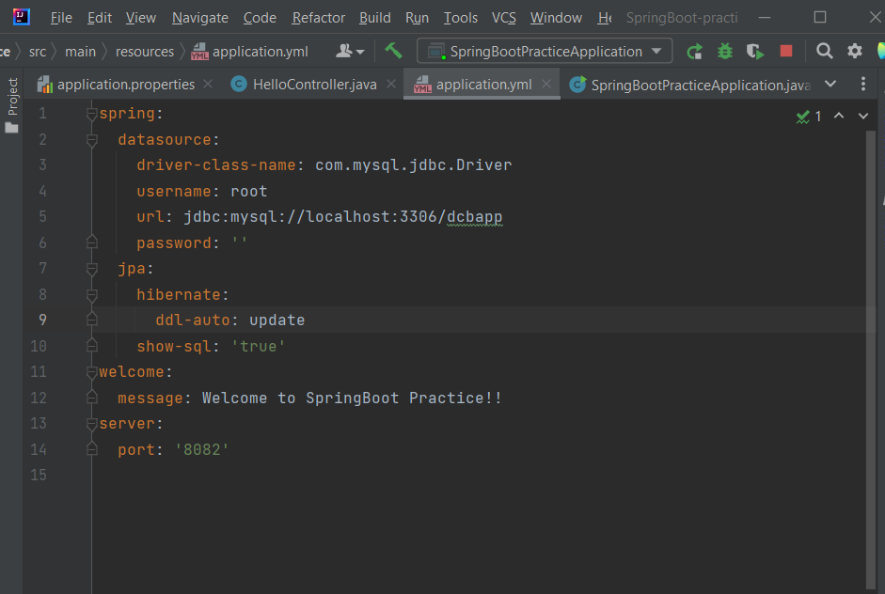

**Profiles help you run your application in different environments** for example different environments having different database from which they run on. Note – correct profiles in application.

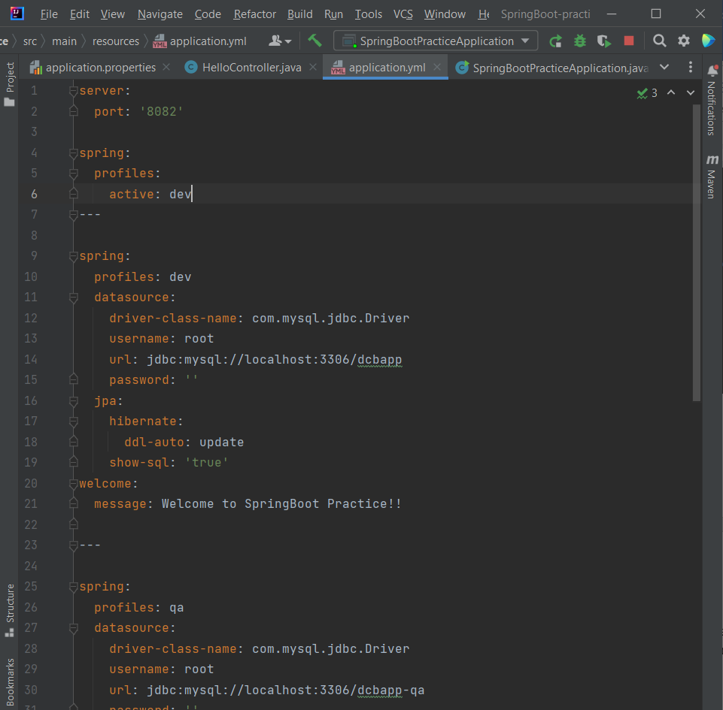

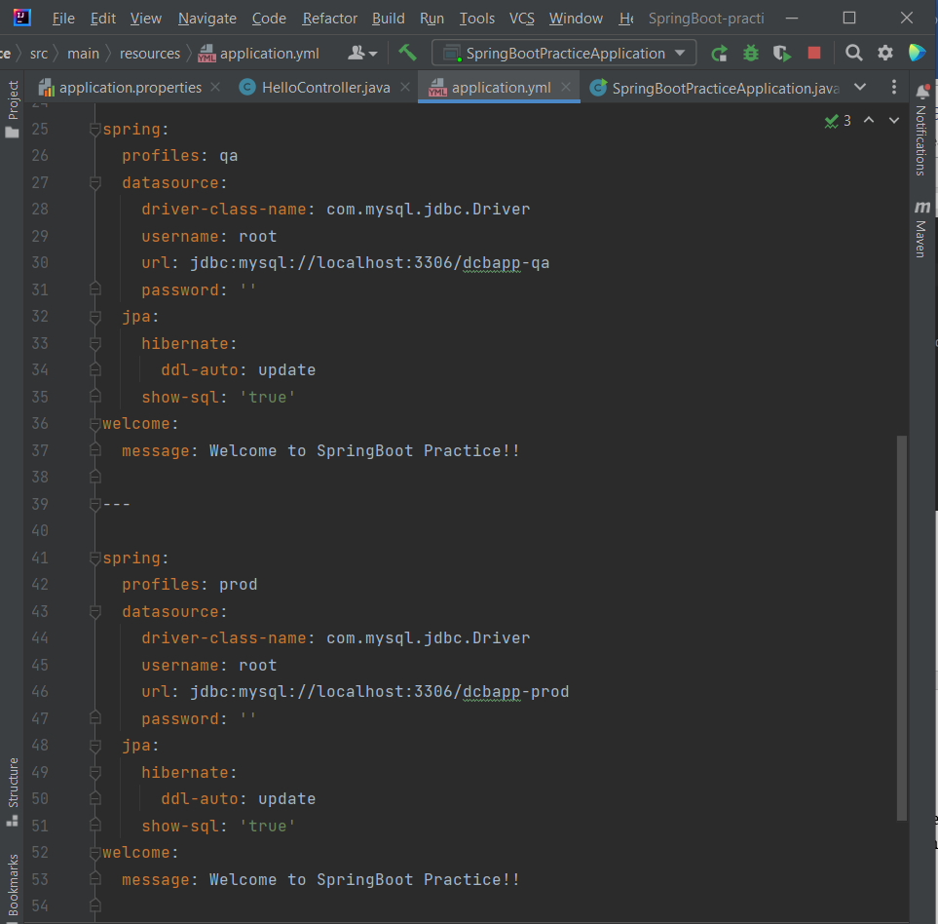

**To create the JAR files that run in production environment run:**

* mvn clean install
* to run it… cd into target folder and type java -jar spring-boot-practice-1.0.SNAPSHOT.jar –spring.profiles.active=prod

if you want it to start it with the prod profile

**SpringBoot actuator** helps us to monitor our application in production

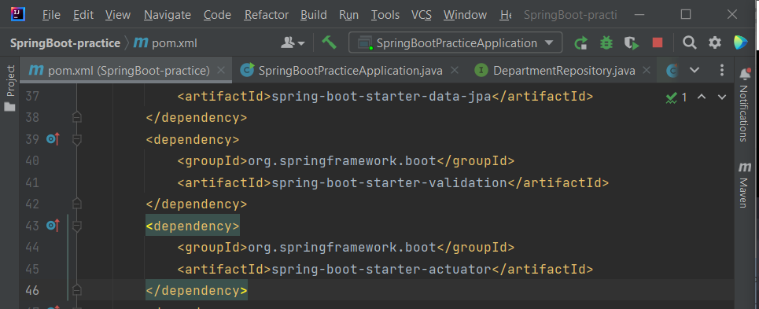

To expose the endpoints that are disabled by default:

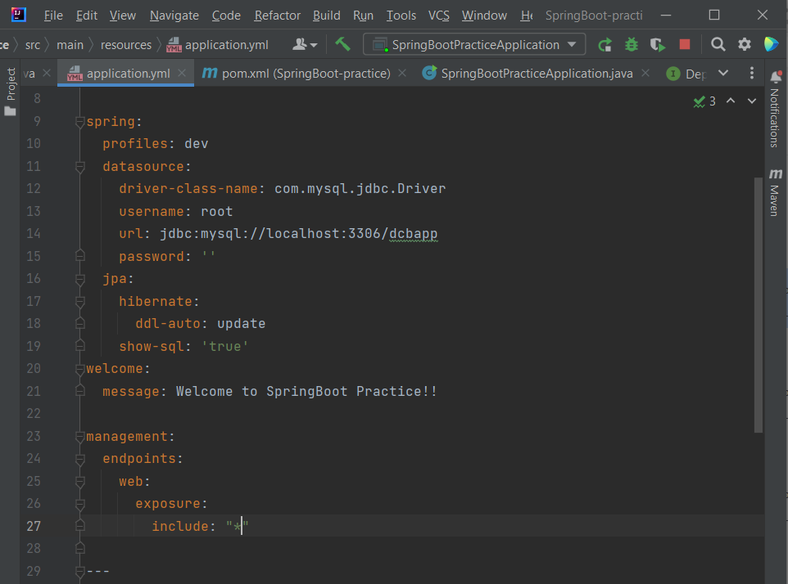

**Making custom actuator endpoints**

@ReadOperation specifies that we’re getting data.

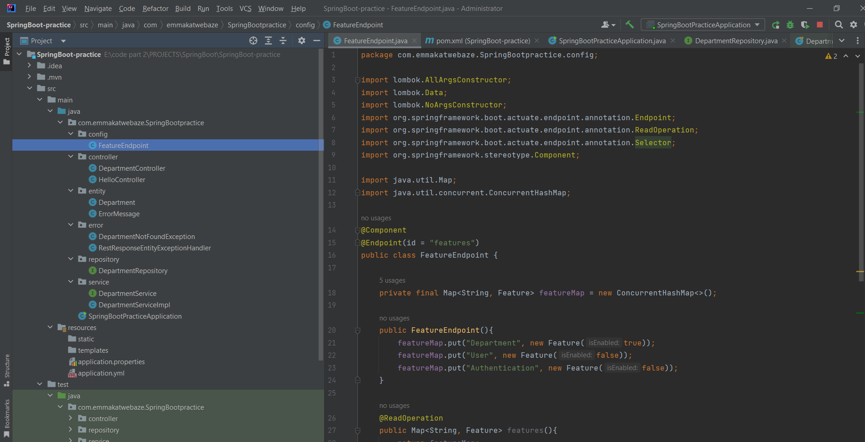

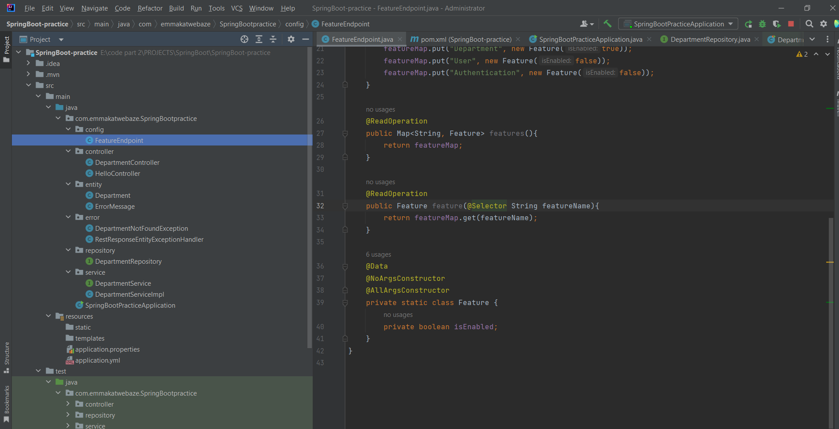

To exclude actuator endpoints:

